Payroll Processing & Finalization Manual
Payroll Processing & Finalization Manual

Treantly

Payroll Processing & Finalization Manual
Calculating, reviewing, locking, and auditing payroll — for Accounting & Super Admin
Covers: Payroll tab · Finalize/Unfinalize · Exports · Audit Report
In this manual
- Getting Started
- Calculating Payroll
- Reviewing Results & Badges
- Margin Alerts
- Deductions: HMO & Loans
- Incentives & Adjustments
- Finalizing & Reopening a Period
- Salary on Hold
- Exporting Payroll
- Audit Report
- Tips & Troubleshooting

From Approved Timesheets to a Locked Payroll
flowchart TD A["Timesheets approved or client-approved for the period"] --> B["Payroll tab: set exchange rates, click Calculate"] B --> C["Review the table: rates, stipends, on-call pay, badges"] C --> D{"Needs a correction?"} D -- Yes --> E["Edit Incentive or Adjustment inline"] E --> C D -- No --> F["Finalize Payroll (locks the period)"] F --> F2["Payroll approver signs off (auto-emailed)"] F2 --> G["Export Breakdown / Wise Existing / Wise New / Import Paid Employees"] G --> H{"Mistake found after finalizing?"} H -- Yes --> I["Unfinalize (reason required, logged)"] I --> B H -- No --> J["Cross-check on Audit Report tab"]

1Getting Started
Payroll lives on the same page as timesheets: Accounting → Payroll opens the Timesheet List page, which has six tabs — Timesheets, Missing/Draft, Margin Alerts, Payroll, Wise Exports, and Audit Report. This manual covers the last four. All six tabs share the same filter bar and stat cards at the top of the page, so whichever Year, Month, and Period you pick applies everywhere — there's no separate period picker inside any individual tab.
💡
A Refresh button sits next to the page title. This page only reloads its data when it first opens or when you change the filter — it never notices something changed elsewhere, like a payroll approver approving from a link in their own email. Click Refresh to pick that up without losing your place (current page, open tab, etc.) or reloading the whole browser tab.
Period is always one of two semi-monthly halves: 1st to 15th or 16th to month end. Payroll is calculated, finalized, and exported one period at a time.
💡
The Finalize Payroll, Unfinalize, and export buttons are only visible to Accounting and Super Admin roles. Everyone else can still see calculated results, just not change them.

2Calculating Payroll
The Payroll tab's toolbar is two cards side by side. The left card, Exchange Rates & Calculation, is where you set the two exchange rates — 1 USD = __ PHP and 1 CAD = __ USD — then click Calculate. These rates are saved for the period and used to convert any peso- or CAD-denominated deductions/additions into the employee's payout currency.
💡
A single Fetch live rates button fills in both fields at once — USD→PHP from Wise's own published rate, CAD→USD from the Bank of Canada, the same published rate accounting already checks manually. It fills the fields in but doesn't lock them; you can still overwrite either one if the amount to actually book that day is different.
- Only timesheets already Approved or Client Approved are included. Draft, submitted, or rejected timesheets are silently skipped — they'll show Pending on the Payroll tab with no figures until their timesheet is approved and payroll is recalculated.
- If a period is already finalized and locked, Calculate is disabled entirely — you have to Unfinalize first.
- Employees with no Salary record, or a $0 rate, are skipped and listed in a yellow warning banner above the table so nothing goes quietly missing.
- For an hourly employee whose rate changed mid-period, Calculate normally splits their hours by date so each segment is paid at the rate that applied then. If their timesheet came in through Import Hours (see the Timesheet Review Manual) there's no day-by-day log to split against, so it pays the full amount at their current rate instead — flagged in its own warning banner rather than done silently.
- The split's cutover date is the Effective Date HR entered on that rate change (Employee form, Salary & Bank Details — see the Employee Management Manual). Enter the date the new rate should actually start paying out, not the date you happen to be making the edit — a raise processed a few days late, or entered ahead of time, still splits on the real effective date rather than the save date.
- Company holidays (Company Calendar → Holidays tab) only affect Monthly-rate employees — a holiday is excluded from that period's working-day count, so their pay isn't reduced and they don't need a timesheet entry for it. Hourly employees see no effect at all: no pay on a holiday unless hours were actually logged, and no holiday-rate multiplier if they did work it. There's no separate "holiday pay" line item and no link to the PTO balance — it's handled structurally by excluding the date, not as a paid leave transaction.
💡
Both the "no Salary record" and the rate-split warning above show up more often on imported timesheets than on normal TA Portal ones — Import Hours only checks that the Employee record exists, not whether their Salary or daily schedule is set up. Neither warning means the import did anything wrong; it just means that employee's payroll setup needs a look before their pay is accurate.
Next to Calculate, a small X / Y calculated count shows how many of this period's employees already have a payroll result. The button itself reads Calculate the first time and Re-calculate once at least one result exists.
The right card, Totals & Finalize, is always visible — it reads Not calculated across the board until Calculate has run at least once. Once there are results, it shows a currency-by-currency totals table (Net Pay, Fees, Final Amount, On Hold — each prefixed with its currency symbol, with Fees and On Hold shown in red as negative figures, since both reduce what the employee actually receives), plus the period's Finalized & Locked / Not Finalized status and the Finalize/Unfinalize button itself — see Finalizing & Reopening a Period.
💡
The On Hold column is only non-zero once at least one employee in the period has an active Salary on Hold — it's the sum of every active hold for the period, already subtracted out of Final Amount.
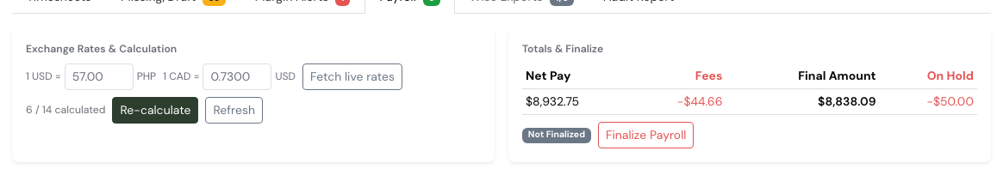
The Payroll tab toolbar: Exchange Rates & Calculation on the left, Totals & Finalize — with real Net Pay, Fees, Final Amount, and On Hold figures — on the right.
If payroll has already been calculated for this period, clicking Calculate again asks for confirmation first, since it will overwrite the existing figures:
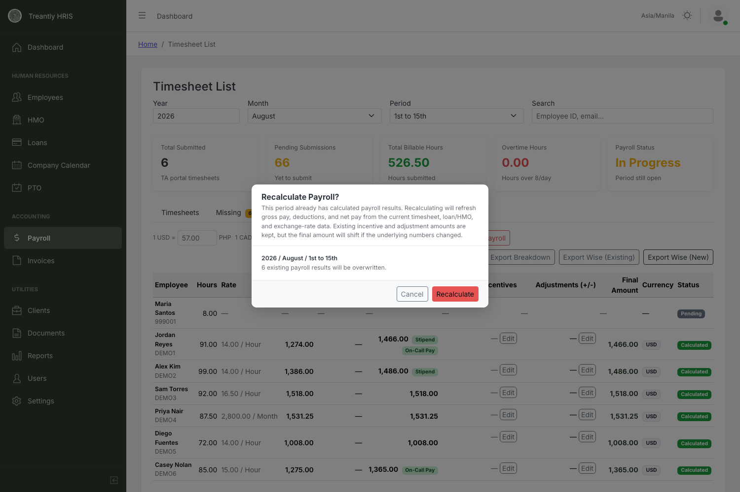
Recalculating refreshes gross pay, deductions, and net pay — but keeps any incentive or adjustment amounts you already entered.
💡
Recalculating is safe to do more than once. It re-pulls hours from the current timesheet state and re-applies the exchange rates, but it never touches incentives or adjustments you've already entered — only the final amount shifts if the underlying numbers changed.
A separate Refresh button next to Calculate reloads the Payroll tab from scratch — it re-fetches the timesheet list, the calculated payroll results, the saved exchange rates, and the lock status for the current period, and resets pagination back to page 1. It does not recalculate anything by itself (that's still Calculate's job) — use it after someone else has changed data in another tab or window and you want this screen to catch up without a full page reload.

3Reviewing Results & Badges
The payroll table columns, left to right:
Column | What it shows
Employee | Name and Employee ID.
Hours | Total approved hours for the period.
Rate | The employee's pay rate and frequency, e.g. 14.00 / Hour or 2,800.00 / Month. A monthly employee's Gross Pay is normally exactly half this figure (2,800 → 1,400) — that half is only reduced for actual unpaid absences during the period, split evenly across the period's working days. See the callout below for exactly what counts as an absence. The Rate column always just shows the flat monthly figure, so a partial month looks identical on screen to a full one.
Gross Pay / Deductions (-) / Net Pay | Standard payroll math — see Deductions: HMO & Loans for what actually feeds the Deductions figure. Net Pay can carry two extra badges (below).
Incentives / Override (+/-) | Manually entered, inline-editable — see Incentives & Adjustments.
Manual Adjustments | Read-only net total of that employee's itemized Payroll Adjustment records from the Timesheets tab, with type/description shown below the amount — already folded into Gross Pay/Net Pay above, not an extra addend. See Incentives & Adjustments.
Fees Deducted | The transfer fee taken out before payout — 0.5% of Net Pay plus 4% of Incentives (Adjustments carry no fee). Shown as a single combined number; see the callout below for why the rate differs by column.
Final Amount | Net Pay + Incentives + Adjustments, minus Fees Deducted. This is the actual payout figure.
Status | Pending (not yet calculated) or Calculated, plus Incentive/Adjusted tags if either is non-zero.
💡
Why the fee rate differs by column: regular payroll (Net Pay) is deducted at 0.5%, Incentives at 4%, and Adjustments at 0% (no fee) — Accounting's transfer-cost breakdown by payment type, not one flat rate applied to everything. All three feed into the single Fees Deducted column above.

Stipend, On-Call Pay, and Overtime Pay badges
An employee's Net Pay cell can show one or more of these small green badges, each with a tooltip:
- Stipend — a flat on-call stipend, capped at one per calendar month regardless of how many separate on-call days were logged, and shared across both the 1-15 and 16-end pay periods (whichever period is calculated first for that month claims it; the other period's own on-call activity that month doesn't add a second stipend).
- On-Call Pay — actual on-call hours paid at the employee's hourly rate × multiplier, shown separately from ordinary worked hours.
- Overtime Pay — for a Monthly-rate employee with Overtime enabled, whatever their cumulative hours for the calendar month (both the 1-15 and 16-end periods combined) exceed their Agreed Hours, paid at their monthly-rate-derived hourly rate × their configured overtime multiplier. Only ever appears on the 16-end calculation — the month's total can't be known until both halves are in, so 1-15 alone never shows this badge even if that half looks high in isolation.
All three are folded directly into Gross/Net Pay — there's no separate column for them, so hover the badge if a number looks higher than expected.
⚠️
Overtime Pay only calculates correctly if the employee's 1-15 period has already been approved by the time 16-end is calculated — an unapproved or still-pending 1-15 timesheet counts as 0 hours toward that month's cap. Calculate periods in order for these employees, or recalculate 16-end after 1-15 is approved if it was run out of order.
⚠️
An employee on an hourly rate who had a rate change mid-period gets a "Rate changed mid-period" badge with a breakdown tooltip. A monthly-rate employee who only worked part of the period for an ordinary reason (new hire, termination, unpaid leave) gets no such indicator — the Rate column looks the same either way, since that's just normal proration, not a change. If a monthly employee's Final Amount looks off for one of those reasons, check their hire/end date and timesheet for that period before assuming the calculation is wrong.
⚠️
This is different from an employee whose pay frequency itself changed mid-period — e.g. an Hourly employee moving to a fixed Monthly rate. That case does get its own indicator: a distinctly-colored "Frequency changed mid-period" badge with a tooltip breaking down each segment's dates, frequency, rate, and subtotal. If more than one salary change lands in the same period (a frequency change plus an unrelated rate bump, for example), the system won't guess — it skips that employee and lists them under a "flagged for manual review" warning instead of auto-calculating something that might be wrong.
💡
What actually counts as an absence for a monthly employee: a working day logged as Unpaid — Full Day deducts a full day's share of the semi-monthly rate; Unpaid — Half Day deducts half a day's share; and a working day with no timesheet entry at all is treated the same as a full unpaid day. Days actually worked, and paid leave (PTO or Emergency Leave, full or half day) are not deducted — those are full pay. A logged Day Off isn't treated as a working day at all, so it doesn't affect the calculation either way. New hires and terminations mid-period work the same way automatically — the days before a hire date or after an end date simply have no timesheet entry to be present on, so pay prorates down to the days actually on the job.

Margin badge
Next to Status, an employee can also carry one of two red/amber badges — see Margin Alerts for the full breakdown of both cases and where else they show up.

4Margin Alerts
A separate nav tab next to Payroll, reading the same calculated results for whichever period is currently selected. It flags employees whose configured rates would bill the client at or below what's actually paid out — and, since Client Rate and VA Rate can each be denominated in a different currency, employees whose currencies differ with no automatic way to check the comparison at all.
The two badge types
Badge | Meaning
Negative Margin | Confirmed. Both rates were reduced to an hourly-equivalent (and converted to the same currency, if needed) and the client rate came out at or below the VA rate — this employee is being billed at cost or a loss.
Margin Unverified | Couldn't be checked. Client Currency and Staff Currency differ, and there's no conversion path available (anything involving PHP — live conversion only covers CAD↔USD). This isn't a claim that the margin is bad, only that it couldn't be confirmed either way. Check the employee's Salary card manually.
A VA Rate + Flat Fee employee gets its own version of the confirmed case: a Negative Margin badge fires only if the flat fee itself is $0, since worked hours on that arrangement bill at cost by design and generate no margin either way.
💡
The Margin Alerts nav badge and each row's badge use the same red-vs-amber distinction: red only appears if at least one confirmed negative-margin employee exists in the period; if every flagged employee is only currency-unverified, the badge shows amber instead.

Client Margin in the payroll-approval email
Finalizing a period (see Finalizing & Reopening a Period) emails every active payroll approver a sign-off request with an Excel workbook attached. Two of its sheets — Client Margin and Negative Margin — build a per-client view that goes further than this tab's own per-employee badges:
- Every client with at least one currently-Hired employee gets a row, not just clients with billable activity that period — a qualifying client with nothing billed or spent yet still shows up at $0 rather than silently dropping off the list.
- A per-client Remarks field surfaces HR-entered context whenever a client's margin is known to run negative (e.g. a front-loaded first-half period against a flat monthly cap), so a reviewer isn't left guessing at a number the team already understands.
- A client billed Monthly has its flat rate correctly halved for a 1st–15th snapshot — comparing half a month's real cost against half the month's revenue, not the full month's. (Previously this compared half a month's cost against the whole month's billed rate, flattering every Monthly client's first-half margin regardless of how its costs actually fell across the month.)
- A Monthly-billed client's margin is instead evaluated once a month, at 16th–end, by combining both halves' real cost and billed figures — rather than being re-flagged as an incomplete snapshot every single half-period.
- On-call pay, on-call stipends, and non-deduction manual adjustments are counted as pass-throughs — added to both Billed and Cost equally, since the client is billed for them dollar-for-dollar — rather than read as pure cost with no offsetting revenue.
A Billed Month (Est.) figure also appears alongside a Monthly client's halved Billed total during a 1st–15th snapshot — the undivided full-month rate, shown for reference only (it's not part of the margin math itself), so a reviewer isn't comparing the halved Billed figure against a whole month's revenue without realizing it.

5Deductions: HMO & Loans
The Deductions (-) column on the payroll table is the sum of whatever HMO and loan amounts apply to that employee for that exact pay period — it is never a flat, every-period charge. Both are set up on the employee's own record (the HMO card and the Loans page), not on this payroll screen.
⚠️
"Active" does not mean "deducts every period." An HMO or loan only deducts on the specific periods its own payment schedule actually generated — everything else correctly shows — in Deductions, even while the benefit itself shows as Active. This is the single most common source of "why isn't this deducting" confusion — check the schedule before assuming it's a calculation bug.

How the schedule is built
Field | What it controls
Effective Date | Where the schedule starts generating terms from.
Deduction Terms (HMO: max 4, a quarterly-style count) | How many scheduled terms exist in total, starting from Effective Date. A low number (e.g. 2) means only 2 specific periods ever get a deduction — not every period between now and eternity.
Amount Deduction per Term | The flat amount charged on each of those specific scheduled periods — not a running/prorated figure.
Loans work the same way, via their own payment schedule — a fixed number of installment terms generated from the loan's own Release Date, each with its own scheduled period and amount. Unlike HMO's 4-term cap, Loans has no maximum Terms value — set it to whatever the actual repayment period is.
💡
An employee can have more than one loan at once — each is its own independent record with its own schedule, so a second loan doesn't replace or merge with an existing one still being paid off.

Deductions stop automatically once fully paid
Every scheduled term — HMO or loan — has its own Paid flag. Payroll only deducts a term that's both (a) scheduled for the exact period being calculated, and (b) not yet marked paid. Once every term in a schedule is paid, that HMO or loan simply stops appearing in Deductions from then on — nothing needs to be manually turned off.
💡
A term is normally marked paid automatically when its payroll period is finalized — not at Calculate time. Recalculating a period before finalizing it is safe to do repeatedly; it won't prematurely mark anything paid.

Where to check or edit a schedule
Open the employee's HMO card or the Loans page to see the full list of scheduled terms for that benefit — each row shows its period, amount, and paid status. This is also where you'll find the exact list of which periods a schedule actually covers, if a period you expected to see a deduction on shows — instead.
💡
Changing a schedule after the fact, moving an HMO term to a different period, toggling a loan term's Paid status, or regenerating either one, doesn't retroactively update payroll that's already been calculated for that period. If a deduction you expect isn't showing on the Payroll tab, click Calculate again for that period — it isn't live, it only reflects whatever the schedule looked like the last time you ran it.
⚠️
HMO and loans handle corrections differently. A loan term's Paid status can still be toggled manually, for a correction (e.g. it was actually paid outside the normal finalize flow). An HMO term has no manual override at all — Paid is set exclusively by payroll finalization. What an HMO term can do instead is move to a different pay period, as long as the new period still falls within that term's own 3-month renewal cycle (a dropdown on the term row offers only the valid periods) — useful if an employee asks for their deduction to land on a different paycheck. A loan term's period isn't editable this way.
💡
An HMO's renewal cycle is every 3 months from its Effective Date. If a cycle's terms have gone stale (their periods are already in the past and unpaid), use Regenerate unpaid on the HMO card — it rolls the schedule forward to the current cycle instead of recreating the same expired dates, without touching any term that's already paid.
💡
If an HMO or loan is quoted in a different currency than the employee's salary, the deducted amount is converted using the exchange rate entered for that pay period (see Calculating Payroll). A missing exchange rate doesn't block the calculation — it just skips that conversion and flags it as a conversion warning instead of silently guessing a rate.

Migrating a loan with payments already made elsewhere
This applies to loans only — HMO has no manual Paid toggle, so there's no way to backdate an HMO term as already-collected (see the warning above). For a loan, when setting up one for an employee who already had installments collected before this system tracked them (e.g. data migration), enter the real, original start date and the true total term count — even if that date is in the past. Let the schedule generate normally, then open the payment list and manually toggle Paid on whichever terms were already collected. This preserves an accurate historical record and leaves only the genuinely outstanding terms to deduct going forward.
⚠️
This does not retroactively fix a term whose period is already finalized and was never actually collected — payroll never reaches backward into a period that's already been processed. Toggling it "Paid" would just misrecord it as collected when it wasn't. A genuine past gap like that needs to be collected some other way (e.g. as an Incentive/Adjustment on a current period) — there's no automatic catch-up.

Extending a loan
If an employee asks for more time to pay off an existing loan, increase its Terms value (e.g. 3 → 5) and click Regenerate Schedule. Already-paid terms are never touched or recreated — only the additional terms get added, continuing on immediately from wherever the existing schedule left off.

6Incentives & Adjustments
Click Edit next to either the Incentives or Override (+/-) value for a row to enter it inline — no modal. Each has an amount field and a free-text Note field, then Save or Cancel.
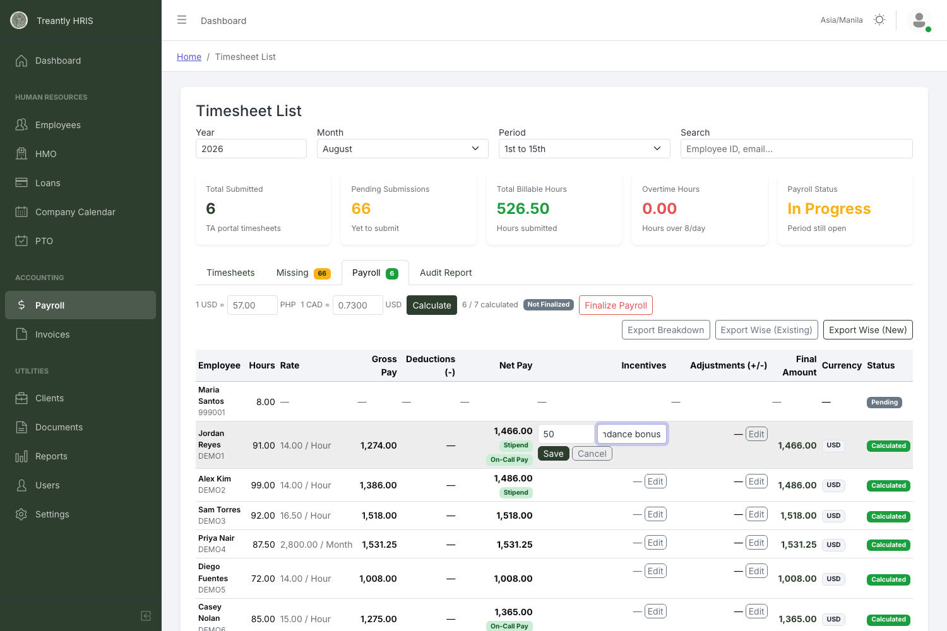
Editing an Incentive inline — amount and a short note, no separate modal.
- Incentives must be zero or positive — there's no negative-incentive option.
- Override (+/-) can be positive or negative, since one field covers both additions and deductions via its sign.
- Every Override save is logged — click View history under that cell to see who changed it, from what amount to what, and their note.
- Both are blocked once the period is finalized — the Edit buttons stay visible but saving returns an error until the period is unfinalized.

Manual Adjustments column
The separate, read-only Manual Adjustments column shows the net total of an employee's itemized Payroll Adjustment records — the ones added via the "+ Add" button on the Timesheets tab (Bonus / Deduction / Tax / Manual Adjustment / Other, each with its own description and currency). These records already feed into Gross Pay/Net Pay during calculation; this column exists purely so you can see that total, itemized, without switching tabs. When there's more than one item behind the total, each item's type and description appears in small text right below the amount.
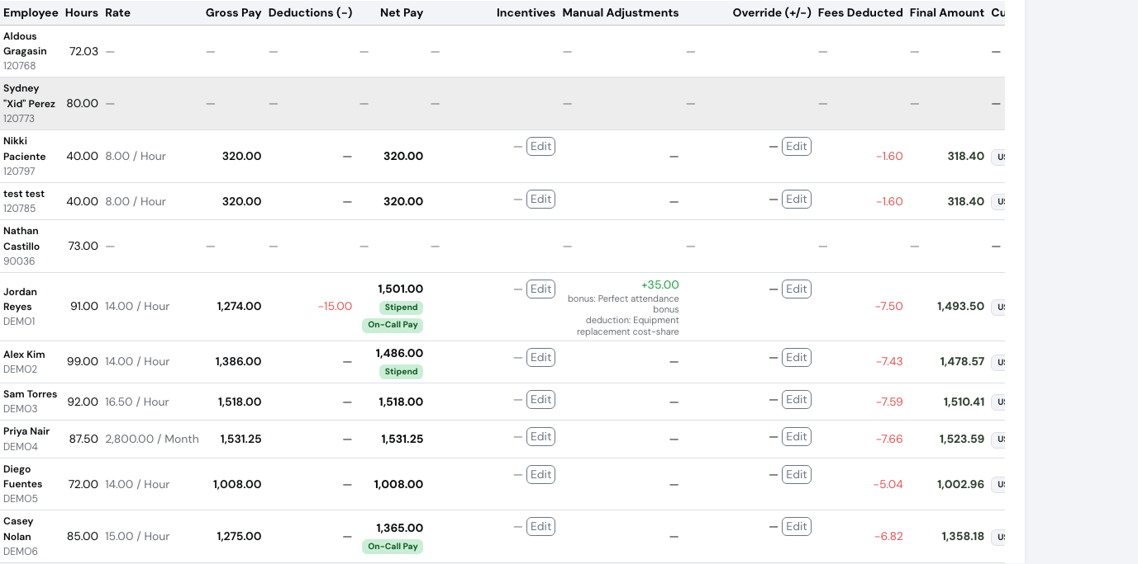
Manual Adjustments (read-only itemized total, with each item's type and description below it) next to Override (+/-) (the separate manual override edited on this row).
💡
Manual Adjustments and Override (+/-) are two different mechanisms that used to share one confusingly similar column name ("Adjustments (+/-)"). Manual Adjustments is read-only here — edit those records from the Timesheets tab's own Payroll Adjustments list. Override (+/-) is the one field you edit right on this row: a single manual override applied on top of the already-calculated result.

7Finalizing & Reopening a Period
Once the numbers look right, click Finalize Payroll. This locks the period: no more calculating, editing incentives/adjustments, or deleting results until someone unfinalizes it. The lock also reaches outside the Payroll tab — itemized Payroll Adjustment records (the Timesheets tab's own "+ Add" list) can't be added, edited, or deleted either, and a timesheet in that period can no longer be approved or rejected, by HR or by the client, until it's unfinalized.
⚠️
If anyone in the period has a Margin Alert, the confirmation modal lists them by name before you commit — split between confirmed negative-margin employees and currency-unverified ones, so you can tell at a glance whether it's worth double-checking before finalizing. It doesn't block Finalize; it's a warning, not a gate.
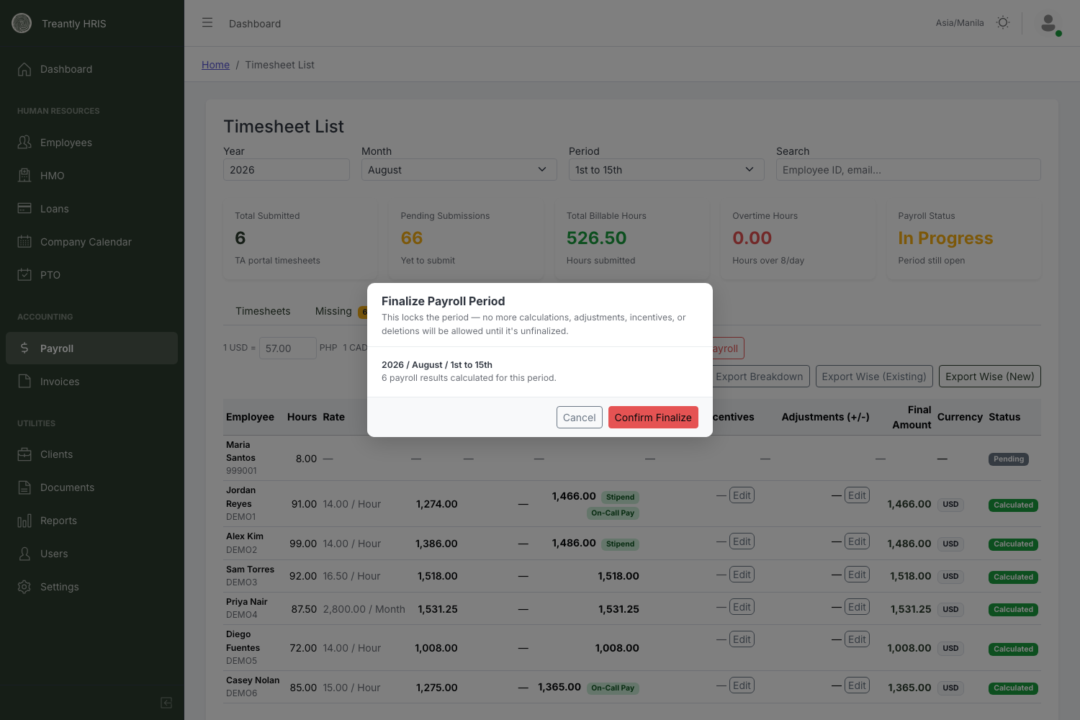
Finalize Payroll Period — locks calculations, incentives, and adjustments for this period.
Finalizing also has one side effect worth knowing about:
💡
Finalizing marks any unpaid HMO and loan installments for that period as paid — but only for employees who actually got a payroll result calculated this run. Unfinalizing later reverses only the installments that specific finalize action marked paid, so it won't accidentally un-pay something settled separately.
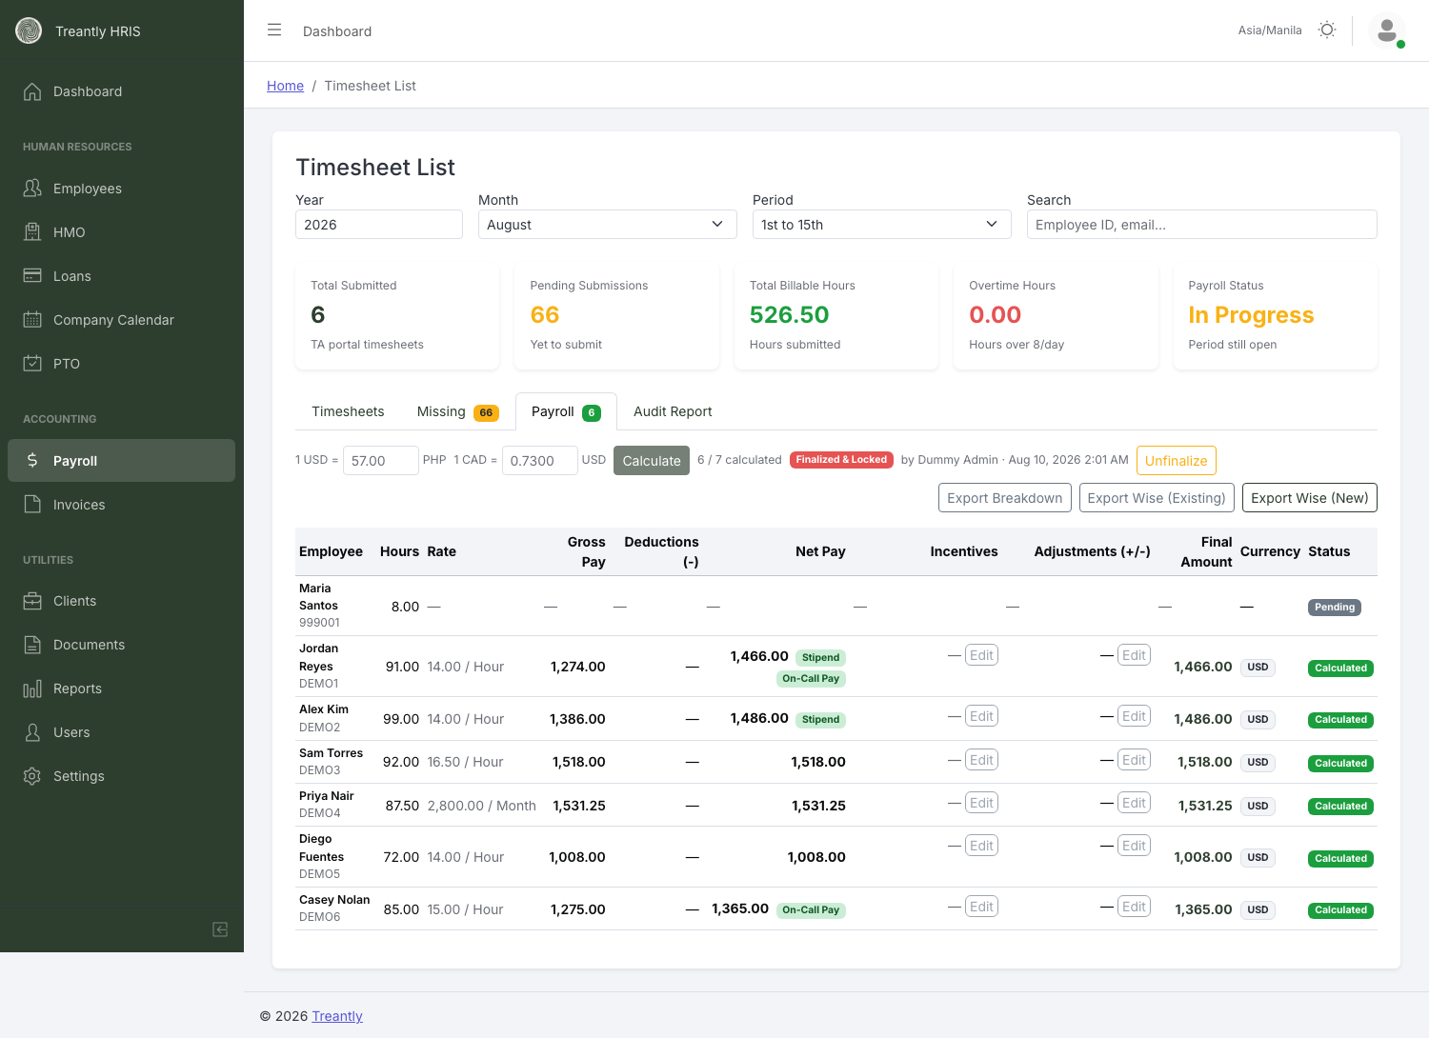
A finalized period: red "Finalized & Locked" badge, who did it and when, and the Unfinalize button in place of Finalize.

Reopening a finalized period
Click Unfinalize. Unlike Finalize, this requires a Reason — it's logged for audit purposes and the field can't be empty.
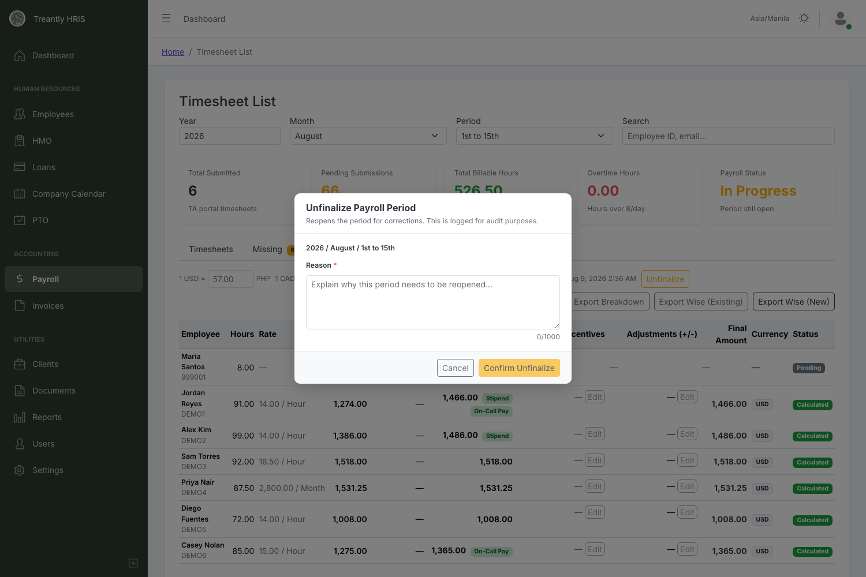
Unfinalizing always asks why — this reason is recorded for the audit trail.
🚫
Unfinalizing doesn't undo an export you've already sent. Nothing stops you from unfinalizing and changing numbers after you've already exported and sent a Wise batch — if you do that to fix something, re-run the export once you re-finalize, otherwise you're paying from a stale file. Exporting itself, though, effectively does require finalizing first: see Wise Exports — the export buttons stay locked until a payroll approver signs off, and sign-off requests only go out once the period is finalized.

8Salary on Hold
A per-employee, per-period hold that carves out part of someone's pay and keeps it out of what actually gets wired this run — used for things like a cash-advance repayment, a disputed amount, or anything else that needs to sit aside without changing the underlying payroll calculation.

Placing a hold
On the Timesheets tab, each row's action buttons include Salary on Hold next to Approve/Reject. Clicking it opens a modal asking for an Amount and a Reason — both required — and records who placed it and when.
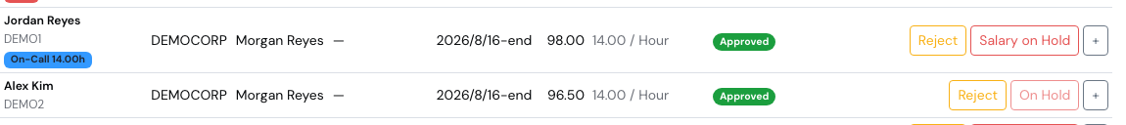
The Timesheets tab: Salary on Hold next to Reject — and the disabled On Hold state once a hold is already active for that employee.
Once an employee already has an active hold for the period, the button itself changes to a disabled On Hold label — place only one hold at a time per employee/period; release the existing one first (from the Salaries On Hold page, below) before placing another.
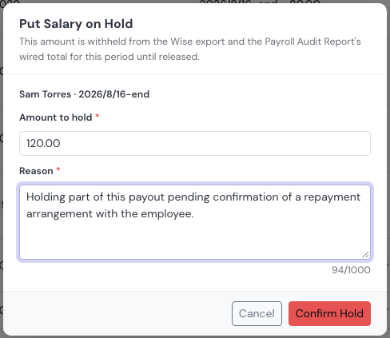
Putting part of a payout on hold — Amount and Reason are both required.
⚠️
A hold only affects what gets wired via Wise — the held amount is subtracted from that employee's Final Amount for the period. It does not block or change payroll calculation itself. A hold placed before Calculate has run for the period won't show its effect on the Payroll tab's totals until Calculate (or Re-calculate) actually runs.

Salaries On Hold (sidebar page)
A dedicated page under the Accounting section of the sidebar lists every hold ever placed — active and released — with a search box and a status filter. Each row shows the amount, reason, who placed it and when, and a Release action for active holds (an optional note can be added when releasing).
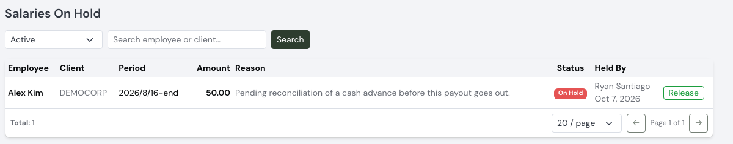
The Salaries On Hold page — search, a status filter, and Release for active holds.

Wise Exports → On Hold tab
The Wise Exports tab (see Exporting Payroll) has its own On Hold sub-tab, next to Flagged — a read-only list of every active hold for the currently-selected period, since a held amount is already subtracted from what shows in Unpaid/Paid there. Release a hold from the Salaries On Hold page, not from here.
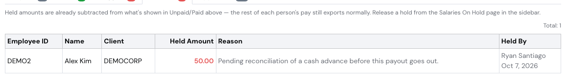
Wise Exports → On Hold: a read-only view of this period's active holds.

9Exporting Payroll
Export Breakdown sits on the Payroll tab itself, disabled until at least one result is calculated — one spreadsheet with every employee's hours, rate, totals, incentives, adjustments, bank details, and client, for internal reference.
💡
The spreadsheet's Adjustments (USD) column is the same combined figure as the Payroll tab's Manual Adjustments + Override (+/-), not just the override alone — and the Notes column lists each itemized Payroll Adjustment's description alongside any override note.
Sending money through Wise is its own tab, Wise Exports, next to Payroll.
⚠️
The Wise Exports tab itself is greyed out and unclickable — not just the buttons inside it — until the period is both finalized and a payroll approver has signed off. Hover the tab for a reminder of which is missing.

Getting unlocked: the payroll approver sign-off
The export buttons stay disabled until a payroll approver has signed off on the period — this is separate from Finalize, and happens after it:
Badge | Meaning
"Finalize this payroll period first" | Not finalized yet — sign-off requests haven't been sent, so there's nothing to wait on. Finalize on the Payroll tab first.
Awaiting Payroll Approver Sign-off | Finalized. Every active payroll approver got an email with a review memo and an Approve/Decline link; none of them has approved yet.
Approved — Export Unlocked | At least one approver clicked Approve — shown with their name and timestamp. Export buttons are live. (Only one approval is needed, not all of them.)
💡
If an approver declines instead, the period is automatically unfinalized (with their reason logged) and every approver is notified — fix what they flagged, then finalize again to re-trigger sign-off requests.
💡
Accounting gets its own email every time an approver acts on a period — approve (whether clean or with a noted-but-overridable issue) or decline — regardless of whether that particular outcome also goes to the full approver roster.

Disbursement Status
At the top of the unlocked Wise Exports tab, before the sub-tabs and the Import Paid Employees button, a line shows this period's overall wire progress per currency: Total − Paid = Remaining. Total is everything that should go out this period (Unpaid and Paid combined), Paid is what's already been confirmed via an imported Wise payout file, and Remaining shows in red while anything's still outstanding and switches to green once the period is fully disbursed.
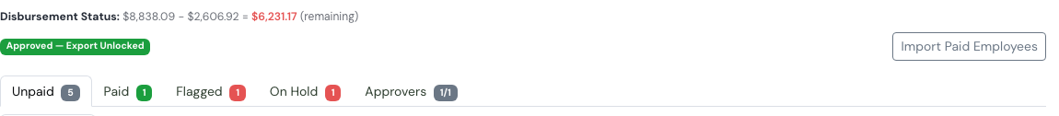
Disbursement Status at the top of Wise Exports, with the Import Paid Employees button and the sub-tab badges.

Unpaid: Existing & New
Once unlocked, the Unpaid sub-tab (badge shows the count) splits into two:
Sub-tab | Who's in it, and the export button
Existing | Employees who already have a Wise recipient ID on file. Export Wise (Existing) downloads a file formatted for Wise's "existing recipient" batch upload.
New | Employees without a Wise recipient ID yet. Export Wise (New) downloads a file that includes their bank details, so you can add them as a new recipient in Wise.
Both files auto-generate a payment reference like 202608A — year, month, then A for the 1st–15th period or B for 16th–end. The amount is each employee's Final Amount from the last calculation — if you recalculate after exporting, re-export before sending the batch to Wise. An employee already marked Paid (see below) is automatically left out of both files, so there's no risk of paying someone twice by re-exporting. An employee whose Final Amount is $0 is also left out — there's nothing to send Wise for them — and won't count toward either sub-tab's badge until a recalculation gives them a real amount.

Confirming payment: Import Paid Employees & the Paid tab
After a batch actually runs in Wise, download its payout-result file from Wise (the one with an apiErrorCode/userErrorMessage column showing which rows failed) and click Import Paid Employees — disabled, like the export buttons, until the period is finalized.
What the import checks | Result
Row matches an employee (by Wise Recipient ID, then email) and its amount matches that employee's Final Amount exactly. | Marked Paid — moves out of Existing/New into the flat Paid sub-tab, with the paid date and Wise's reference number shown.
Row matches an employee, but the amount is different from what was owed. | Reported as an Amount Mismatch and moved to the Flagged sub-tab (see below) — not marked paid, for someone to review; never guessed or auto-accepted.
Row can't be matched to any employee, or matches one with no payroll result for this period. | Reported as No Matching Employee / No Payroll Result.
Row has Wise's own error code/message (the transfer itself failed). | Reported under Wise Errors — never marked paid.
Row matches someone already marked Paid from an earlier import. | Reported as Already Paid — safe to re-upload the same file, nothing changes twice.
The same import also keeps each employee's Wise Recipient ID in sync, and surfaces two more signals alongside the five outcomes above:
Signal | Meaning
Recipient ID synced | The payout file's Wise Recipient ID didn't match what was on file for that employee, so it was written back automatically — nothing to do.
Bank account changed | A recipient ID rotated for someone already on file — not a new hire, the same employee — which usually means they changed banks. Flagged for a manual look rather than silently overwritten.
A payment split across more than one Wise batch is also tracked cumulatively, not just by the latest file — each installment adds to a running total received. The Flagged sub-tab (below) shows Received So Far against Still Owed rather than a single expected/actual pair, and a row that's been partially paid and still shows up in Existing/New carries the remaining balance still owed, not the original full amount.
A Download Report button appears after the upload — an Excel file with one tab per outcome above, for reviewing or fixing before a re-upload.

Flagged
A fifth sub-tab, after On Hold (see Salary on Hold). Unlike the clean outcomes above (which only ever show up in that one upload's result and the downloadable report), an unresolved mismatch is also saved — so it's still visible here even after you've closed the modal or come back another day. Each row shows the Expected amount, Received So Far (the cumulative total across every installment imported so far — not just the latest file), and Still Owed, the difference between the two. A flagged employee also still shows up in Existing/New with a red ⚠ Mismatch badge, since they're still unpaid and need to be paid correctly.
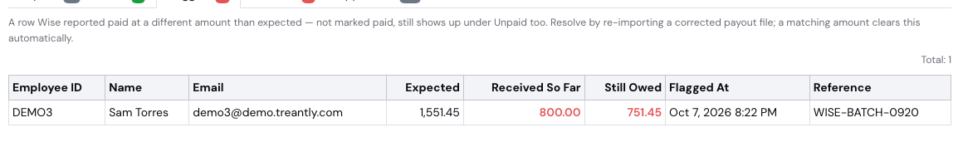
Flagged: a partial payment tracked across separate Wise imports — Received So Far vs. Still Owed.
Resolving a flag isn't a separate action — re-import a corrected (or a follow-up, completing) payout file, and a row whose Received So Far now matches what's owed clears the flag automatically (same import, same rules as any other row).

10Audit Report
⚠️
The Audit Report tab itself is greyed out and unclickable until at least one employee for this period is confirmed paid via Wise (see Wise Exports → Confirming payment) — calculating payroll alone isn't enough to unlock it.
The Audit Report tab compares the current period's payroll against the previous period's, across four sub-tabs: Payroll Audit Report, Raw, New Employees, and Removed Employees.
💡
Don't confuse the tab-access rule above with the report's own Employees Paid stat card, further down — that's an older label meaning "employees with a calculated payroll result," not Wise payment status. The report's numbers (totals, variance, employee counts) are based entirely on calculated results and never change based on how many have actually been paid via Wise.
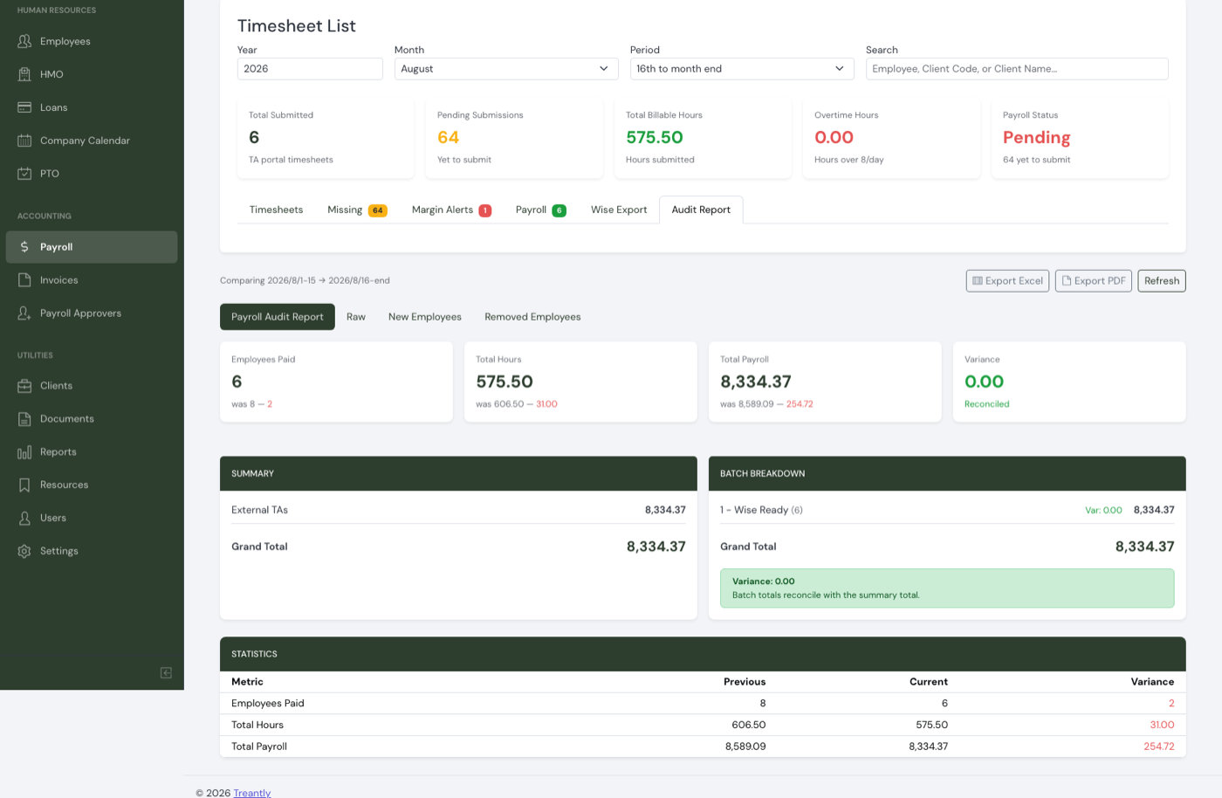
Payroll Audit Report: current-vs-previous stat cards, the External TAs total, batch breakdown, and a reconciliation check.
💡
The Total Payroll stat, External TAs, and Batch Breakdown all sum the same per-row figure (Raw's Grand Total column — Net Pay with a 0.5% transfer-fee deduction, plus Incentives with a 4% transfer-fee deduction, plus Adjustments with no fee), so the Variance card should normally read 0.00 — Reconciled every period. A "Doesn't reconcile" result is worth investigating — check for an employee missing from one side, counted twice, or a manual data issue.
⚠️
Because that shared figure excludes stipend and on-call pay (and applies the transfer-fee deduction — 0.5% on Net Pay, 4% on Incentives, none on Adjustments), the Total Payroll stat and External TAs on this report read lower than the real total amount actually paid out whenever stipend or on-call pay is involved. For the real payout total, use the Payroll tab's Final Amount column or the exports — this report's totals are a Wise-batch estimate, not the actual payroll figure.

Raw
The row-level detail behind the summary — every employee who has a current-period result, with previous vs. current hours and payroll, a Status (Existing / New / Removed), and a Flag (New, Removed, Increase, Decrease, No Change). This table is wide; scroll it horizontally to see bank details and the Batch column.
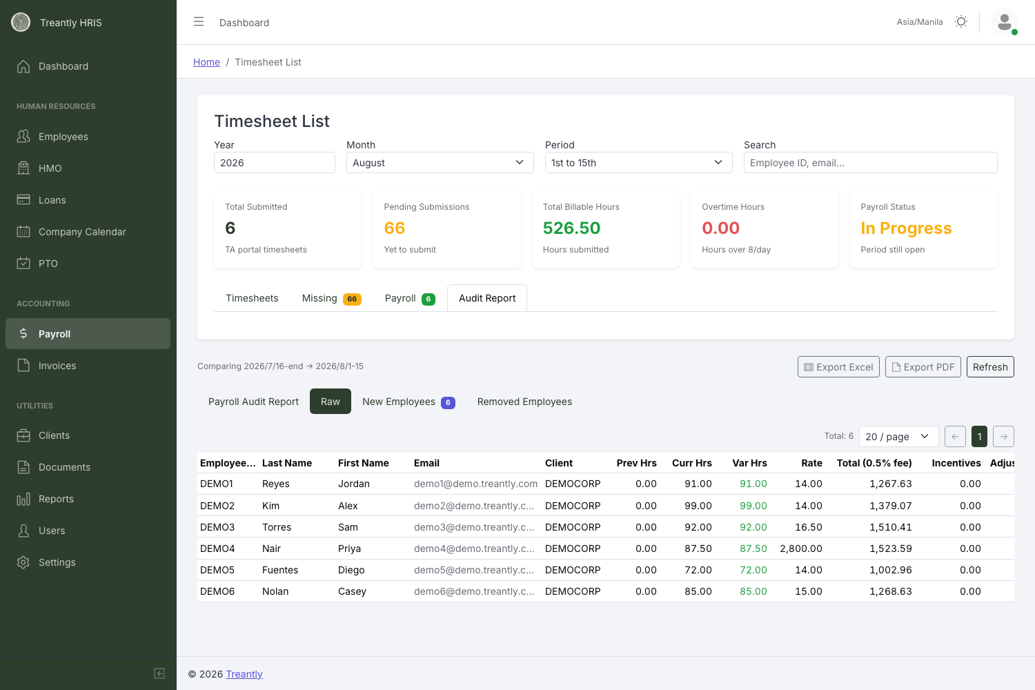
Raw: every current-period employee, previous vs. current figures side by side.
💡
The Raw tab's Grand Total column (Column P in the export) is an audit/display figure, built differently from the Payroll tab's Final Amount — it can come out lower whenever stipend or on-call pay is involved, since those aren't part of the base gross pay this column starts from. It's also the figure the report's Total Payroll, External TAs, and Batch Breakdown totals are all built from. For the actual payout amount, always use the Payroll tab or the exports, not this column.
💡
The Adjustments column is also a combined figure — the manual override amount plus the net total of that employee's itemized Payroll Adjustments for the period, not just the override alone.

New Employees & Removed Employees
New means the employee's Date Hired falls inside the current period — not "first-ever payroll result calculated for them," which used to wrongly flag anyone just newly brought into payroll tracking as a new hire even if they'd actually been employed for years. Removed means their End of Contract date falls inside the current period.
Both tabs include anyone hired or terminated mid-period even if no payroll was ever actually calculated for them — someone terminated early enough in the period (or hired late enough) that no partial-period payroll ran would previously have vanished from the report entirely, not just from these two tabs.
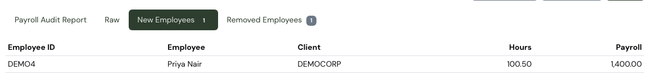
New Employees: an employee whose Date Hired falls inside this period.
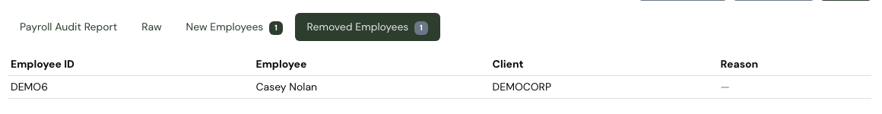
Removed Employees: an employee whose End of Contract falls inside this period. A Reason column exists but stays blank until an exit reason is logged elsewhere.
Export Excel downloads all four views as one workbook. Export PDF does not download a file directly — it opens your browser's print dialog with the report laid out for printing. Choose "Save as PDF" there to get a file.

11Tips & Troubleshooting
Situation | What's actually happening
An employee shows Pending with no figures after Calculate. | Their timesheet for this period isn't Approved or Client Approved yet. Approve it on the Timesheets tab, then recalculate.
Calculate button is greyed out. | The period is finalized and locked. Unfinalize it first (requires a reason).
An employee is missing entirely from the Payroll tab. | Check the yellow warning banner above the table — they may have no Salary record, or a $0 rate configured.
Several employees are skipped with "No salary record configured," and they're all recent Imported timesheets. | Expected — Import Hours only needs the Employee record to exist, it doesn't check Salary setup. Open each employee's record, add their job/rate under Salary, then Re-calculate.
An hourly employee's pay looks off for an imported period where their rate also changed. | Check the Calculate warnings for "no daily logs" — an imported timesheet has no per-day breakdown to split by date, so the full amount was paid at their current rate instead of split across the old/new rate. Adjust manually if the split matters for that employee.
Incentive/Adjustment "Edit" doesn't save. | The period is finalized. Unfinalize before editing, then re-finalize when done.
An employee shows Margin Unverified instead of a confirmed margin. | Not a bug — their Client Currency and Staff Currency differ in a pair the live rate can't convert (anything with PHP). Open their Salary card and check the numbers manually; see Margin Alerts.
"Fetch live rate" fails or shows an error toast. | The Bank of Canada (CAD field) or Wise (USD→PHP field) service is temporarily unreachable. Enter the rate manually — Calculate isn't blocked by this.
Audit Report says "Doesn't reconcile." | Not expected — Total Payroll, External TAs, and Batch Breakdown all sum the same figure now, so this should normally read 0.00. Check for an employee missing from the current period, counted in more than one batch, or a recalculation that hasn't been re-exported yet — see the callout in Audit Report.
"Export PDF" on Audit Report opens a print dialog instead of downloading. | That's by design — it's a browser print, not a server-generated file. Choose "Save as PDF" in the dialog.
Re-sent a Wise batch after fixing a number. | Always re-export after any recalculation, incentive/adjustment change, or unfinalize-then-refinalize cycle — exports reflect whatever was last calculated, not what's currently on screen.
Treantly HRIS — Payroll Processing & Finalization Manual · For questions, contact your system administrator.

