PTO & Leave Management Manual
PTO & Leave Management Manual

Treantly

PTO & Leave Management Manual
Approving leave requests and tracking PTO balances — for HR, Accounting & Super Admin
Covers: Leave Requests · Accrual & Usage · Granting PTO
In this manual
- Getting Started
- Leave Types, at a Glance
- Reviewing & Deciding Leave Requests
- Accrual & Usage
- Granting & Adjusting PTO
- Tips & Troubleshooting

From a Submitted Request to an Updated Balance
flowchart TD A["Employee submits a leave request (TA Portal)"] --> B["Balance reserved immediately — before anyone approves it"] B --> C["Shows up as Pending on the PTO page"] C --> D{"HR decision"} D -- Approve --> E["Status: approved Day is paid on the timesheet if it falls inside the request"] D -- Reject --> F["Status: rejected Balance refunded"] E --> G{"Mistake found after approving?"} G -- Yes --> H["Rescind (reason required, balance refunded)"] H --> F G -- No --> I["Done"]

1Getting Started
The PTO page lives at Human Resources → PTO in the sidebar and has two tabs: Leave Requests (the approval queue) and Accrual & Usage (per-employee balances). Both tabs work off every client's employees at once — there's no client filter, just a free-text search box on each tab.
💡
Only Super Admin, HR, HR Admin, and Accounting roles can actually use this page. The sidebar link is visible to everyone, but anyone outside those roles is redirected away if they click it.

2Leave Types, at a Glance
There are two leave types in the system, each available as a Full day or Half day:
Type | Status
PTO | The active leave type. Split into a client-funded pool and a company-funded pool, with the company-funded pool supporting either One-time Input or Accrual grant modes — see Accrual & Usage.
Emergency Leave (legacy) | Retired as of 2026-08-07 — every employee's Emergency Leave balance was zeroed out and no new balance can be granted for it. Existing/pending Emergency Leave requests can still be approved or rejected normally, but the underlying balance well is permanently dry, so a new Emergency Leave request will always fail to reserve a balance.
⚠️
There is no separate "sick leave" or "unpaid leave" type — only PTO and Emergency Leave (legacy) exist in this system.

3Reviewing & Deciding Leave Requests
The Leave Requests tab lists every request, filterable by Status (All Statuses / Pending / Approved / Rejected / Cancelled), Type (All Types / PTO / Emergency Leave (legacy)), and a free-text search. It defaults to showing Pending only. Results are paginated: a footer under the table shows Page X of Y with Prev/Next buttons and a page-size dropdown (10 / 20 / 50 / 100 per page) — the same simple pattern used elsewhere in the app, just without the Employee list's extra jump-to-page controls.
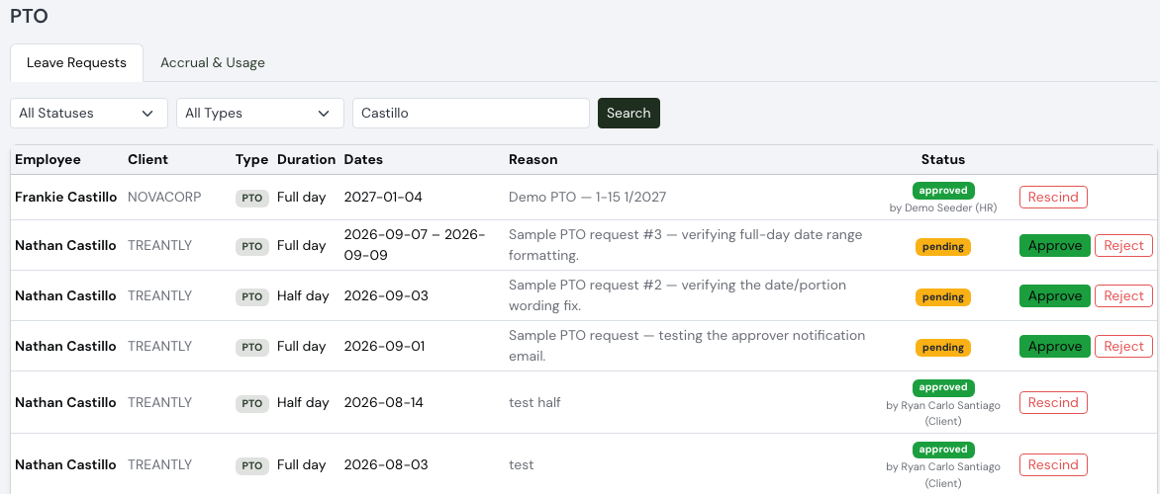
Leave Requests, filtered to All Statuses and searched by employee name: pending rows alongside approved rows showing the real approver’s name and role — “by Ryan Carlo Santiago (Client)” and “by Demo Seeder (HR)”.
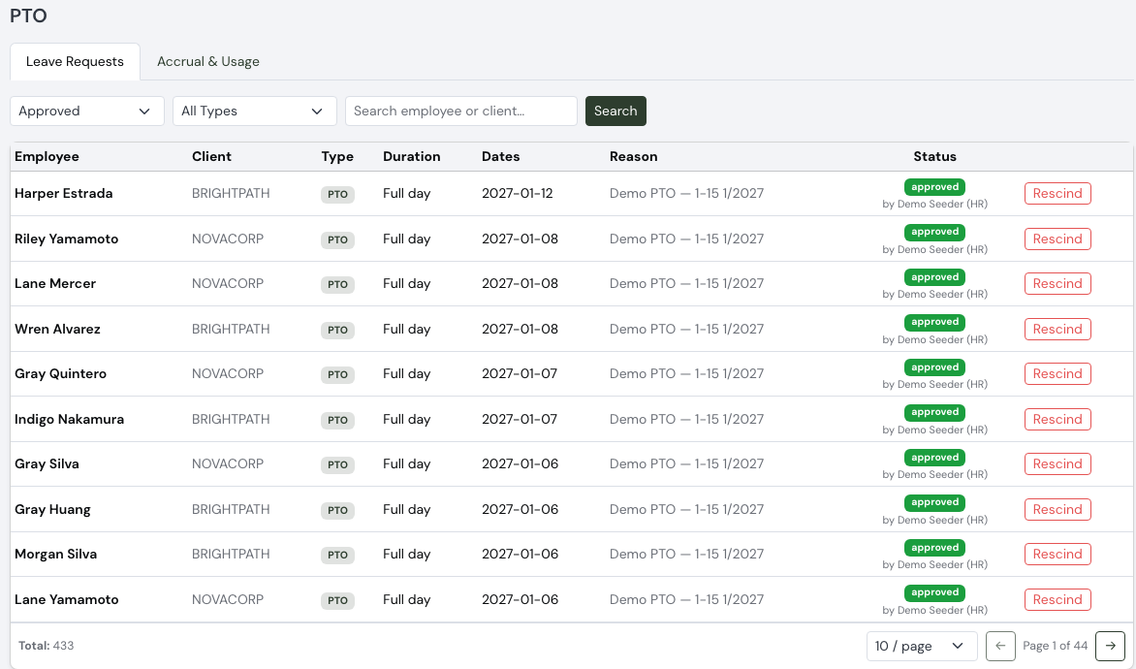
Leave Requests footer: the page-size dropdown and Page X of Y navigation, here filtered to Approved (433 total).
Each row’s Status badge is one of four values, color-coded:
pending approved rejected cancelled
An approved or rejected row also shows by the actual approver’s name underneath, with their role in parentheses — e.g. by Jane Doe (HR) or by Tristan Haque (Client) — so you can tell who made the call and whether the client's own portal already acted on it. Cancelled requests were withdrawn by the employee themself — there's no button on this page for that; it's here purely so HR can see it happened.

Approving a request
Click Approve on a pending row. A confirmation prompt appears — no separate reason needed — then the status becomes approved immediately.

Rejecting a pending request, or rescinding an approved one
Click Reject (on a pending row) or Rescind (on an approved row). Both open the same inline reason field directly under the row — no modal — and both are actually the same action on the backend: whichever state the request was in before determines whether it reads as a rejection or a rescind.
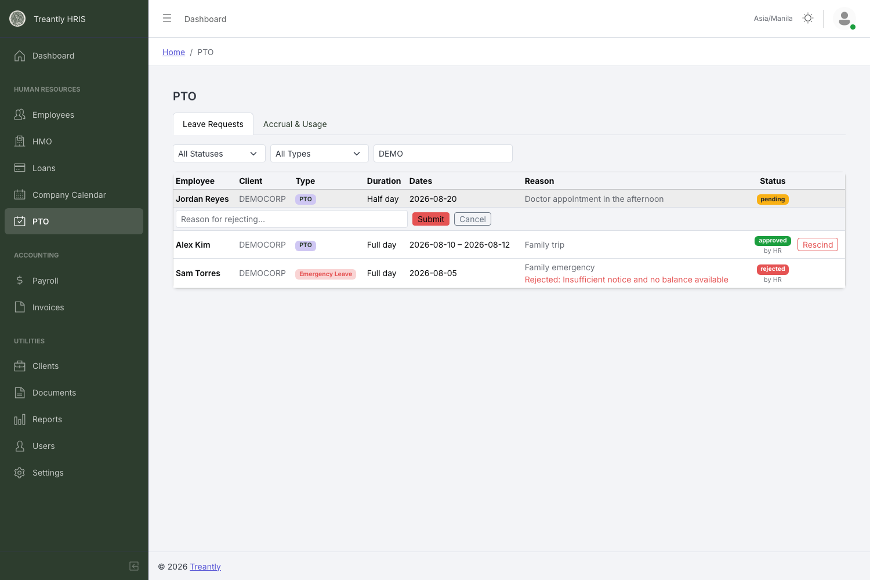
Rejecting a pending request: reason placeholder reads "Reason for rejecting…"
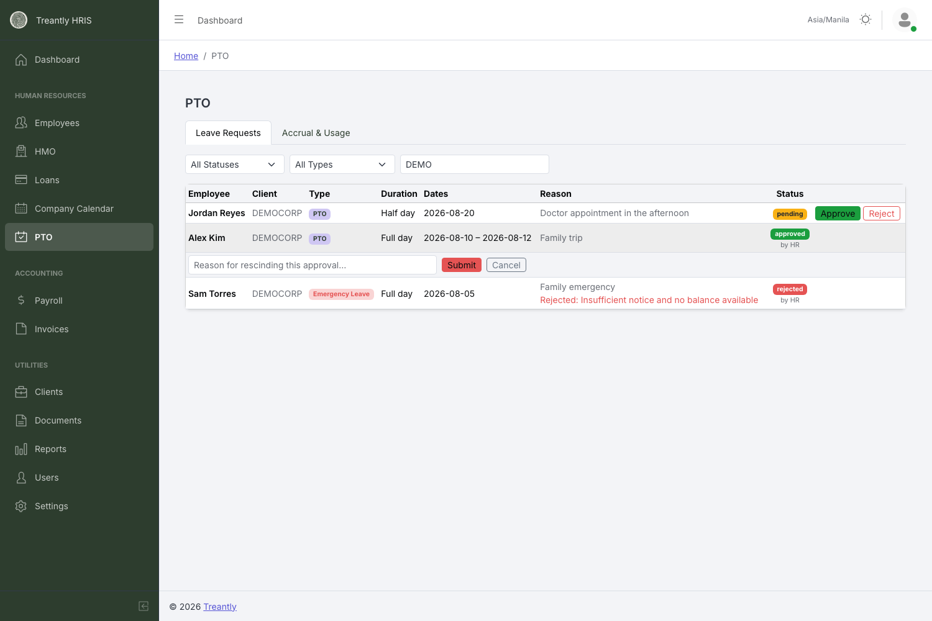
Rescinding an approved request: same inline field, placeholder reads "Reason for rescinding this approval…"
A reason is required in both cases — clicking Submit with it empty just shows a warning and does nothing. Click Cancel to close the field without submitting.
💡
The balance is reserved at submission, not at approval. An employee's PTO balance is deducted the moment they submit a request — approval only decides whether that already-reserved day gets paid on the timesheet. That's why both rejecting and rescinding do the same thing to the balance: they refund the days that were reserved back when the request was first submitted.
🚫
Rescinding does not automatically fix an already-processed timesheet or payroll. If the leave day in question was already paid through a finalized payroll run before you rescind the approval, the balance is refunded but nothing goes back and corrects that payroll — you'll need to handle that manually through the Payroll tab's Incentives & Adjustments if it's already been paid out (see the Payroll Processing & Finalization Manual).

4Accrual & Usage
The Accrual & Usage tab shows each employee's running PTO balance for a chosen Year (defaults to the current year), searchable by employee or client.
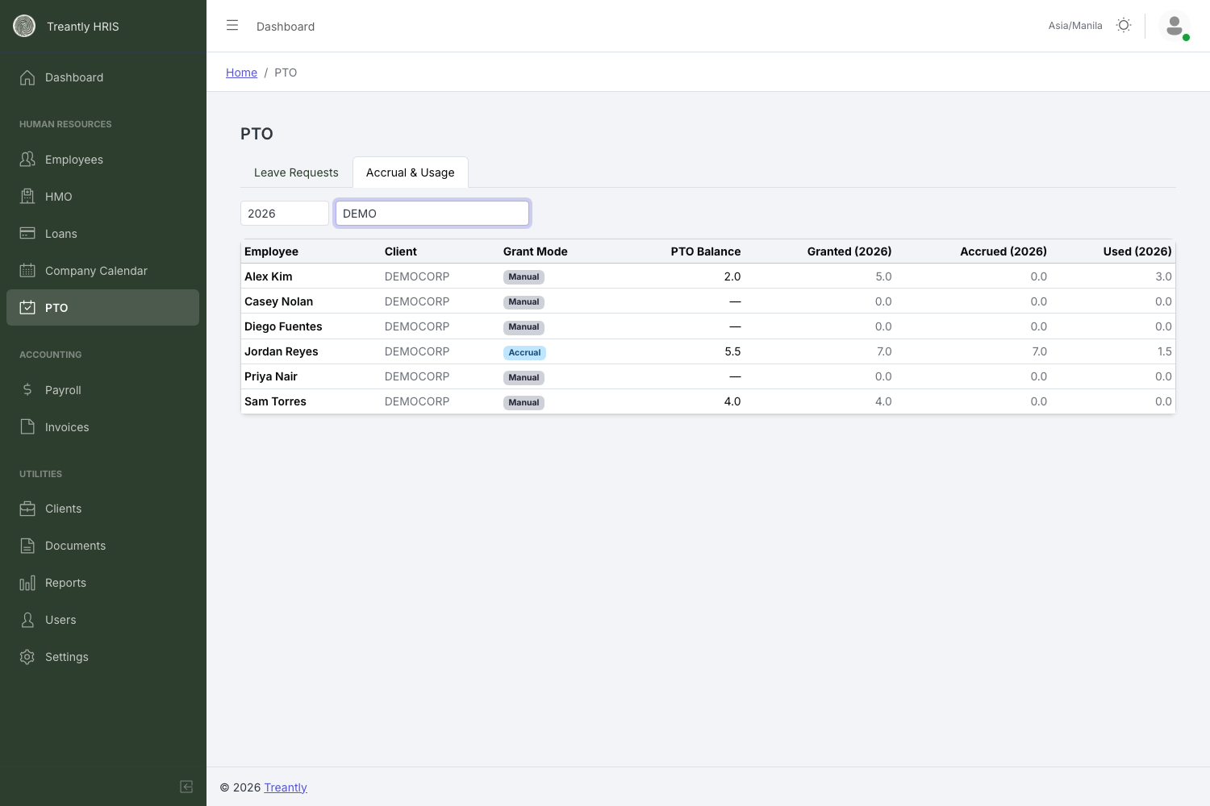
Accrual & Usage: a mix of Manual and Accrual grant modes, with granted/accrued/used broken out for the year.
PTO is split into two independently-tracked pools, plus a computed total and a live usable balance:
Column | What it means
Client-Funded Bal. | A flat, directly-edited number — a fixed contractual amount of PTO the client is funding for this employee. Always editable, regardless of Grant Mode.
Client Payment Status | To Be Billed — the client is billed per PTO hour as it's taken. Already Paid — it's already folded into the client's flat monthly billing, so nothing extra is billed when the employee takes it.
Company-Funded (Limit) | Not a live balance — it's a ceiling: the most company-paid PTO this employee can ever be granted. Editable by HR at any time.
Total of both PTO | Computed, never typed directly — Client-Funded Bal. + Company-Funded (Limit).
Available PTO | The actual, live, spendable balance — this is what gets deducted when leave is taken. In One-time Input mode it stays synced to Total of both PTO automatically, but only by however much the total actually changes — it's never reset outright, so it never erases days already taken. In Accrual mode it grows +1/month via the scheduled accrual job instead.
Grant Mode | One-time Input — Available PTO tracks Total of both PTO directly. Accrual PTO (+1/month) — Available PTO instead grows automatically, one day per month, independent of Total of both PTO (though it's still capped by it).
Hours per PTO Day | How many hours a full day of PTO or Emergency Leave is worth for this employee (a half day is half of it) — defaults to 8, capped at this employee's own scheduled shift length. Raise it to 12 for someone working a 12-hour shift, so a PTO day pays out the hours they'd actually have worked, not a flat 8. Lives right next to Grant Mode and Available PTO in edit mode.
Granted (year) | Manual grants plus accrual credits combined, for the selected year.
Accrued (year) | Just the automatic monthly-accrual portion, broken out separately from manual grants.
Used (year) | Days deducted for requests, minus any refunds from rejected/rescinded requests, for the selected year — broken out by whether the day drew from the client-funded or company-funded pool.
⚠️
Switching an employee to Accrual mode part-way through a month withholds their first +1 credit until the following month — it doesn't grant a partial day retroactively. It also resets Available PTO to 0, or 1 if Grant the first day immediately was checked at the moment of the switch — that's an intentional fresh start for the new mode, not a bug.
💡
This tab only shows active employees — anyone terminated won't appear here regardless of year selected. It also only ever shows PTO columns; Emergency Leave balances exist in the system but aren't displayed on this tab.

5Granting & Adjusting PTO
Everything PTO-related is edited on the employee's Edit form on the Employees page — there's nothing to configure from the row itself. Open an employee and edit Client-Funded PTO, Client Payment Status, and Company-Funded PTO (the limit) directly; Total of both PTO next to them is a disabled, computed preview.
In edit mode, a second row adds Grant Mode (One-time Input or Accrual PTO (+1/month)) alongside a disabled Available PTO preview showing what the live balance is (or is about to become). The moment you switch Grant Mode from One-time Input to Accrual, a Grant the first day immediately checkbox appears — leave it unchecked to start Available PTO at 0 with the first credit arriving next month, or check it to start at 1 right away. Grant Mode changes aren't applied immediately — they save together with the rest of the form when you click Save.
💡
Editing Client-Funded PTO or the Company-Funded limit on a routine save only adjusts Available PTO by however much the total actually changed — it never resets it outright. That means days an employee has already taken stay deducted even if you update an unrelated field on their record afterward.
Every grant, deduction, refund, and accrual credit is logged in Recent History right below the form — date, funded pool (client or company), action (Grant / Deduct / Refund / Accrual), amount, resulting balance, reason, and who made the change. This is the same log that feeds the Granted/Accrued/Used columns on the Accrual & Usage tab.
💡
Only pto can be granted through this form going forward — Emergency Leave is retired, so there's no way to add to that balance anymore even though old Emergency Leave history entries stay visible for reference.

6Tips & Troubleshooting
Situation | What's actually happening
An employee says they can't submit a new leave request. | Check their Available PTO on the employee's Edit form or the Accrual & Usage tab — the balance is reserved at submission time, so a request that would exceed what's left is rejected before it's ever created.
Rejecting and rescinding show the exact same success message. | Expected — they're the same underlying action. The only difference is whether the row was pending (reject) or approved (rescind) beforehand.
Rescinded an approval, but the employee was already paid for that day. | Rescinding only refunds the Available PTO balance — it does not reach back into an already-finalized payroll. Use the Payroll tab's Incentives/Adjustments to correct the pay if needed.
Available PTO doesn't match Client-Funded + Company-Funded (Limit) anymore. | Expected once any PTO has actually been taken while in One-time Input mode — Available PTO only moves by however much Total of both PTO changes, so it stays below the total by exactly what's been used. It's shown in red on the Accrual & Usage tab whenever it exceeds the total, which would indicate a real problem worth investigating.
Switched an employee to Accrual mode but their balance didn't move this month. | Expected if the switch happened mid-month — the first +1 credit applies starting the following month, never retroactively.
An Emergency Leave request is still pending, but there's no balance to approve it against. | Emergency Leave was retired 2026-08-07 and every balance was zeroed. You can still approve or reject the request itself, but there's no way to grant a new balance for it — treat any remaining Emergency Leave requests as legacy cleanup, not an ongoing benefit.
Treantly HRIS — PTO & Leave Management Manual · For questions, contact your system administrator.

