TA Portal User Manual

Treantly

TA Portal User Manual
A guide to logging your hours, tracking your schedule, and viewing your pay — for Treantly Assistants
Covers: Employee Information · Timesheet · Payroll Calendar · Payslip · Manual
In this manual
- Getting Started
- Employee Information
- Timesheet
- Payroll Calendar
- Payslip
- Tips & Troubleshooting

Your Journey Through the Portal
flowchart TD A["Sign in (Assistant ID + Client Code)"] --> B{"New hire?"} B -- Yes --> C["Complete Onboarding checklist"] C --> D["Employee Information"] B -- No --> D D --> E["Timesheet: fill in hours, leave, on-call"] E --> F["Preview & Submit"] F --> G{"Client / HR review"} G -- Rejected --> E G -- Approved --> H["Payroll finalized"] H --> I["Payslip available"] D -.check anytime.-> J["Payroll Calendar: submission windows & holidays"]

1Getting Started

Logging In
Open the TA Portal link shared by your Treantly team. There's no password — sign in with the two details on file for you:
- Assistant ID — your unique employee identifier
- Client Code — the code for the client you're assigned to
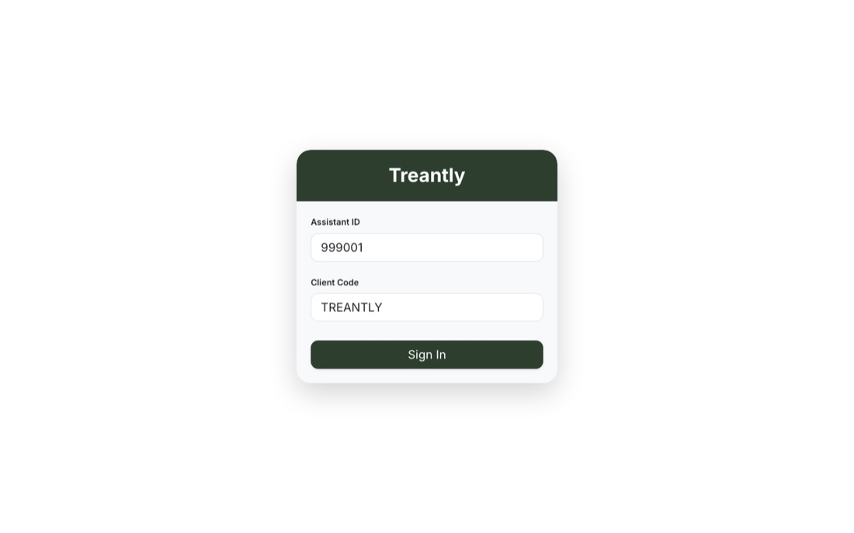
Signing in with an Assistant ID and Client Code — no password required.
⚠️
After 5 failed sign-in attempts, the form locks and you'll need to try again later. If you're not sure of your Assistant ID or Client Code, contact your Treantly team rather than guessing repeatedly.
If your account is still in On-boarding status, signing in takes you straight to your onboarding checklist (documents to review and sign) instead of the main portal. Once onboarding is complete, you'll land on Employee Information every time you log in.
🔒
This isn't just a redirect — until your onboarding checklist is submitted, Timesheet, Payroll Calendar, Payslip, and every other section stay unavailable, even if you navigate to them directly. Submit the checklist first; everything else opens up right after.

Finding Your Way Around
The sidebar on the left is available from every page and always shows:
- Your local timezone, at the top
- The five main sections: Employee Information, Timesheet, Payroll Calendar, Payslip, and Manual (this guide, available any time from the sidebar)
- Your current PTO and Emergency Leave balances, in days
- Your name and role at the bottom, with a logout button
↑ Back to top

2Employee Information
This is your home page — a read-only record of everything Treantly and your client have on file for you.
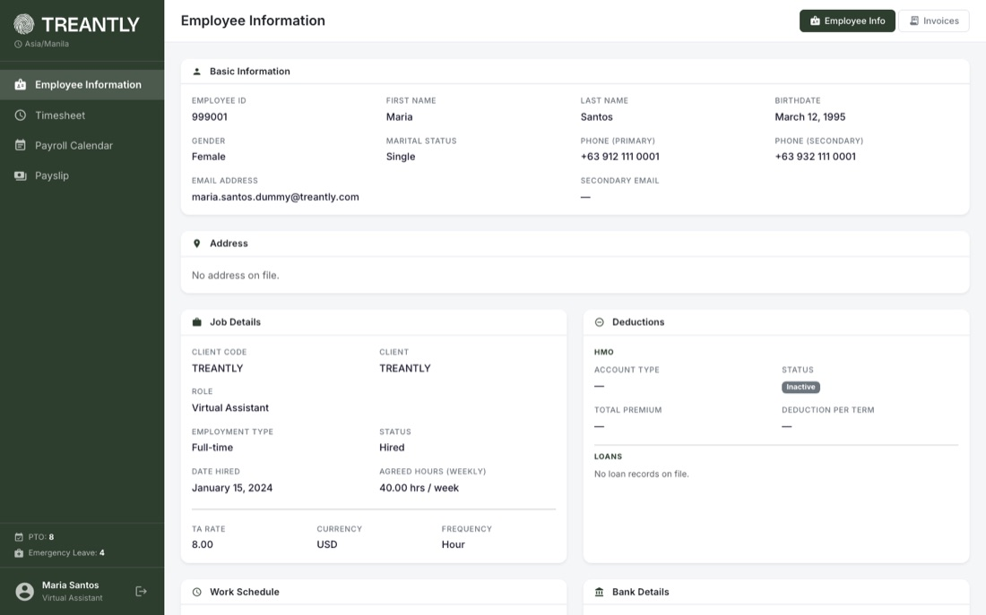
Employee Information — Basic Information, Job Details, Deductions, and more, all in one read-only page.

Employee Info tab
- Basic Information — name, birthdate, gender, marital status, contact numbers, and email addresses
- Address — your address on file, or a note if none has been added yet
- Job Details — client, role, employment type, status, date hired, agreed weekly hours, and your rate/currency/pay frequency
- Deductions — your HMO plan (type, status, premium) and any active loan records (amount, deduction per payroll, status)
- Work Schedule — your timezone and a day-by-day breakdown of scheduled start/end times and unpaid breaks. If a day's scheduled span works out to more than your account's daily standard, it's flagged with a badge like >8h — expected hours for that day are always capped at your standard regardless. Most accounts are capped at 8 hrs/day; some are set to 12 for a 12-hour shift, so the badge threshold shown may read >12h instead — check with your Treantly team if you're not sure which applies to you
- Bank Details and Emergency Contacts (primary and secondary)
💡
Everything on this page is maintained by HR. If anything is missing or incorrect, let your Treantly team know — you can't edit it directly from the portal.

Invoices tab
Reserved for client invoice visibility. It's currently a placeholder — nothing appears here yet.
↑ Back to top

3Timesheet

The submission window
Each pay period runs 1st–15th or 16th–end of month. You have 3 days after a period ends to submit its timesheet, plus a leeway until 6:00 AM Philippine time the following day — most clients are US-based, so a shift can run right through PH midnight, and this gives you a few hours after a late shift ends to still get it in.
A badge at the top of the page shows the deadline. More than 3 days out it just shows the date ("Due Sep 19"); once you're within 3 days, it switches to a live countdown ("1h 39m left") that ticks down by itself while the page is open — no need to refresh. Once it hits zero, that period locks for input.
You can only work with the current or the most recently closed period — the arrows next to the period label won't let you go further back or jump ahead.
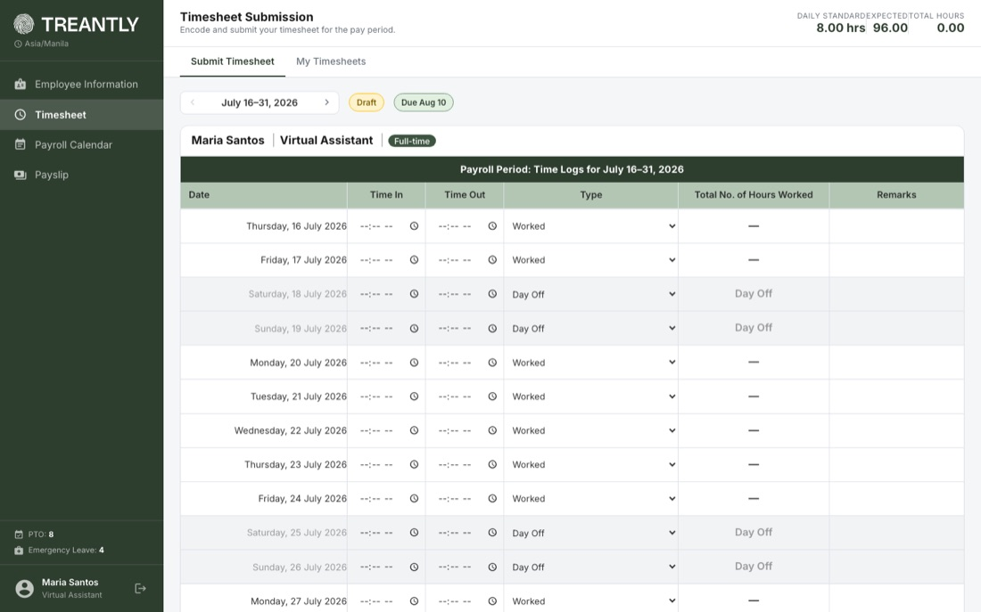
A fresh period, ready for hours — the deadline badge and period navigator sit at the top.

Hours imported from historical records
For a period that predates your TA Portal access, HR may bring your hours in directly from an existing record instead of asking you to re-submit them. When that's happened, this page shows a simple summary — your total hours for the period — instead of the usual day-by-day form, with a banner at the top explaining where the hours came from.
💡
This isn't something you submitted, so there's nothing to fill in or fix here. If the total looks wrong, contact your Treantly team rather than trying to edit it — the fields are intentionally locked for imported periods.

Filling in your hours
- 1For each date, enter your Time In and Time Out. Hours are calculated automatically.
- 2If the day isn't a normal worked day, use the Type dropdown instead:
  - Worked — the default; time in/out applies
  - Day Off — not a scheduled work day, contributes 0 hours
  - PTO – Full Day / Half Day
  - Emergency Leave – Full Day / Half Day
  - Unpaid Leave – Full Day / Half Day
- 3Add a note in Remarks if needed (not available for Day Off rows).
💡
A full-day PTO or Emergency Leave credit uses your own account's daily standard (8 hrs for most people, 12 for a 12-hour-shift account) — a half day credits half of that. If your credited hours look off, check your Work Schedule on the Employee Information page.
PTO is never picked manually from the Type dropdown. Once a PTO request is approved (from the Leave Requests tab), the matching day in your timesheet fills in by itself the next time this page loads — there's nothing you need to do. This only fills in a day that's still blank; it won't touch a day you've already set to Day Off or a different leave type.
💡
If you'd already typed Time In/Out for that day before the request got approved, the auto-fill still applies and replaces those hours with the PTO credit. You'll see a toast like the one below, naming the exact date(s) that changed, so nothing disappears without a trace. If you actually worked that day, contact your Treantly team — once a day is auto-filled as approved PTO, its Type dropdown locks, so you can't switch it back to Worked yourself.
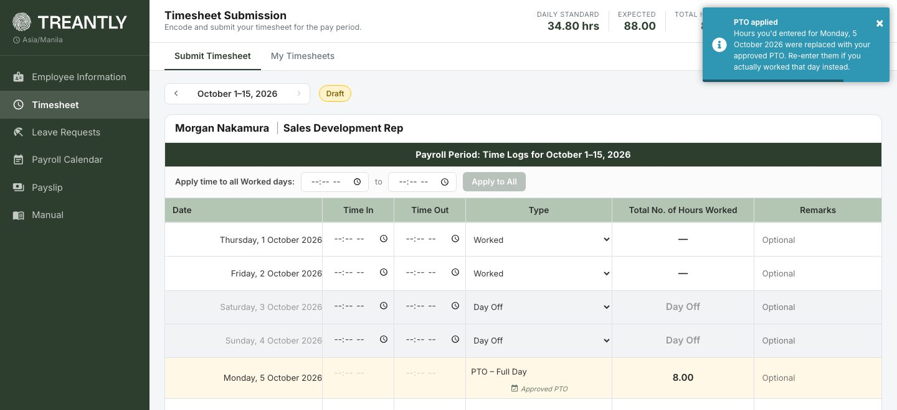
An approved PTO request auto-filling Monday, 5 October. Since hours were already typed in for that day, a "PTO applied" toast lists exactly what was replaced.
💡
Overnight and 24-hour shifts are supported. If your Time Out is earlier than your Time In (e.g. 10:00 PM – 6:00 AM), it's counted as a normal overnight shift, not an error — those hours land on this day's row. Setting Time Out equal to Time In (e.g. 8:00 AM – 8:00 AM) means a full 24-hour shift.
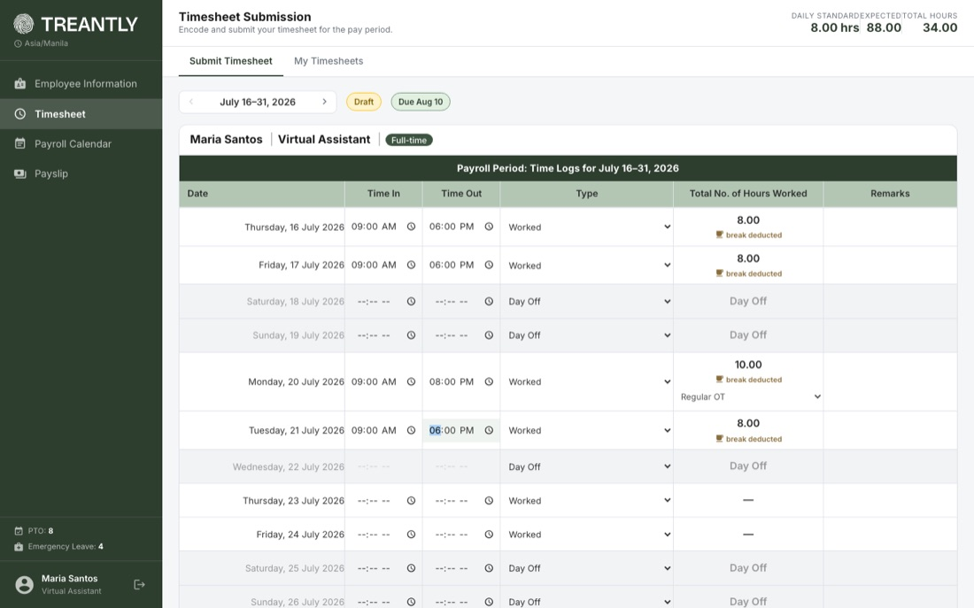
A filled-in week: normal days, a break-deducted note, an overtime day with its OT type selector, and a Day Off.
☕
If your scheduled shift includes an unpaid break and your logged time fully covers it, the break is automatically subtracted from your hours for that day — you'll see a "break deducted" note under the total.

Reporting a break
If your schedule doesn't have a fixed unpaid break configured, or your actual break varies day to day, use + Break next to + Shift once you've entered a Time In and Time Out for that day. It adds a break entry right in the same sequence — Time In/Time Out for when the break started and ended — and shows up muted with a Break tag so it reads clearly against your worked time. It never counts toward your total hours; it's there purely to show when the break happened.
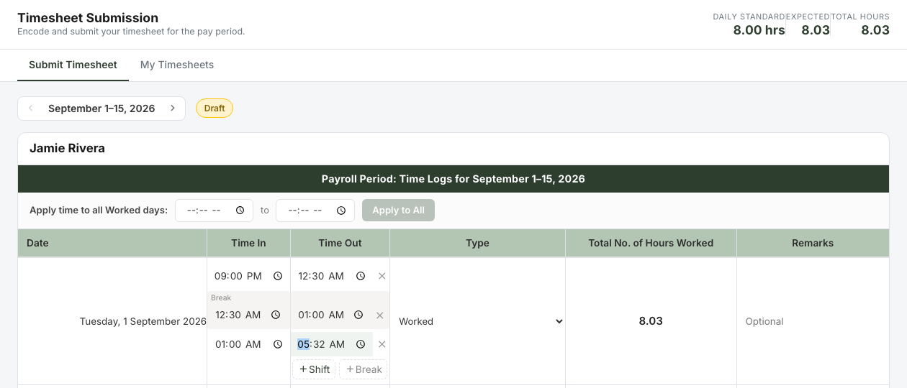
A Work → Break → Work day: 9:00 PM–12:30 AM worked, a break from 12:30–1:00 AM, then 1:00–5:32 AM worked. The break contributes nothing to the 8.03-hour total.
☕
This is separate from the + Shift button, which is only for employees with a split-shift schedule (a second distinct work block, like a second job in the same day). Anyone can use + Break, regardless of whether Shift is available to you.

Overtime
Hours beyond your scheduled daily standard (8 hrs/day for most accounts; 12 for a 12-hour-shift account) are flagged as overtime on that row, and the period total appears in the top bar as Period OT. For any day with overtime, pick the matching OT type: Regular OT, Rest Day OT, or Holiday OT.
⚠️
Overtime must be enabled on your account to submit hours above your period's expected total. If it isn't, Confirm & Submit is blocked with a message like "This timesheet has X hours over the Y-hr expected for this period. Overtime isn't enabled for this account." Contact your Treantly team if the extra hours are legitimate — they can enable overtime for your account.

Monthly Overtime Cap
If your account is on a fixed monthly rate with overtime enabled, a Monthly Cap stat appears in the top bar (and again in the Confirm & Submit preview), showing your hours used against your monthly agreed-hours cap and how much is left, e.g. 101.00 / 174.00 (73.00 left). This is separate from Period OT above — the cap tracks your whole calendar month, combining both the 1-15 and 16-end halves, not just the period you're currently viewing.
This tile only shows for you if it applies to your account — it reflects your own hours only. It updates live as you enter hours for the period you're currently on, added to whatever the other half of the month already had approved.
💡
Going over your monthly cap doesn't block or change how you submit — you enter your hours the same way either way. Any excess is reconciled automatically once both halves of the month have been submitted and approved; check your payslip for the exact amount.
⚠️
The counter only counts a period once it's been approved. If the other half of the month is still awaiting approval, the counter won't include its hours yet, and may understate your true total until that approval goes through.
Once your cumulative month hours actually go over that cap, a second stat — Monthly OT (Est.) — appears alongside it, showing just the excess in hours (e.g. +36.00 hrs). This is the same figure payroll's Monthly Overtime Pay calculation pays out once both periods for the month are Calculated — shown here as a running estimate before payroll runs, so it isn't a surprise later. It appears in the live top bar while you're filling in hours, in the Preview & Submit summary, and in the read-only View of a past timesheet (see My Timesheets (history) below) for any period that pushed the month over the cap.
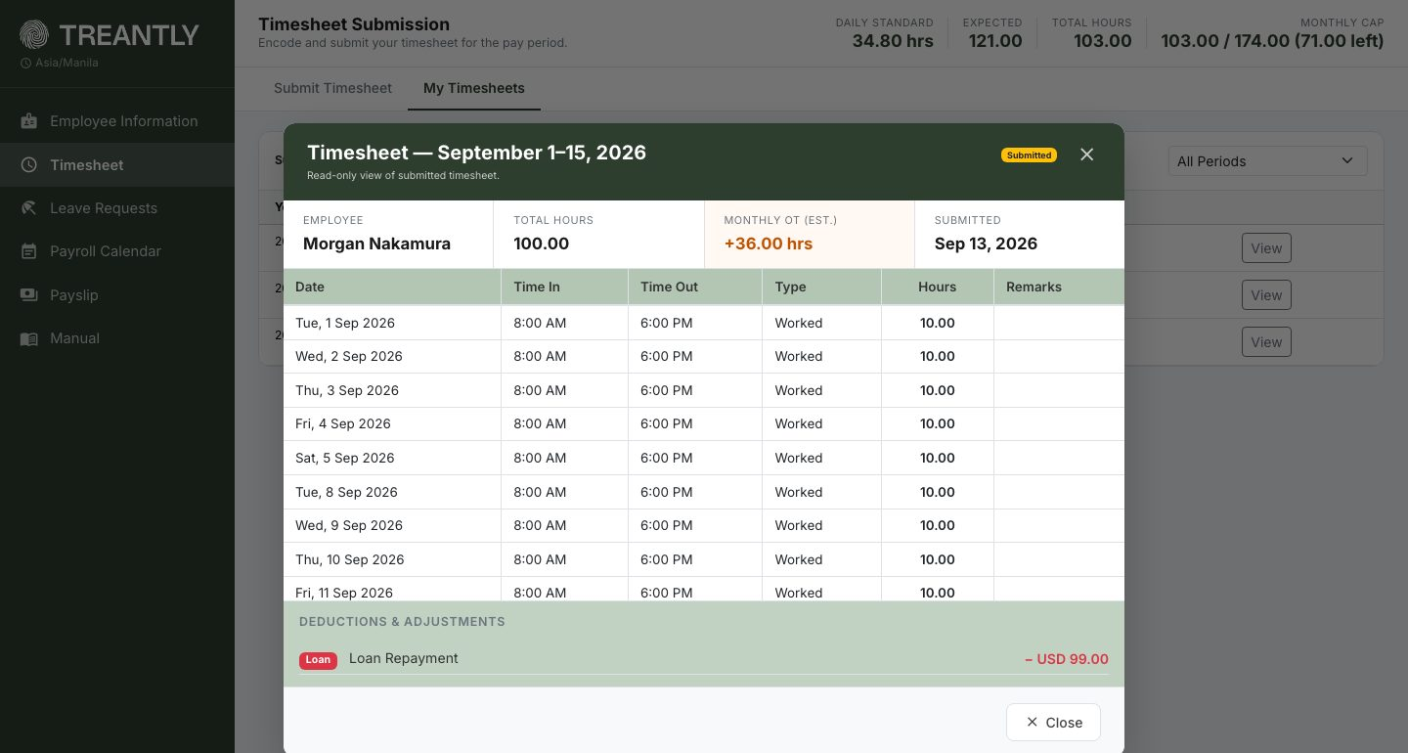
The read-only View of a past timesheet showing Monthly OT (Est.) — this period's hours, combined with the other half of the month, came to 36.00 hours over the 174-hour monthly cap.
💡
This is an estimate, not something you need to act on — it previews what your Monthly Overtime Pay will be once both halves of the month are calculated. Check your payslip once payroll runs for the final, actual amount.

On-Call Hours
If on-call work has been enabled for your role, an On-Call Hours card appears below the main table. Click + Add On-Call Hours to open the Add On-Call Dates picker — choose a From and To date and click Generate to add one blank row per date in that range. If you don't see this card, on-call isn't enabled for you — check with your Treantly team if you think that's a mistake.
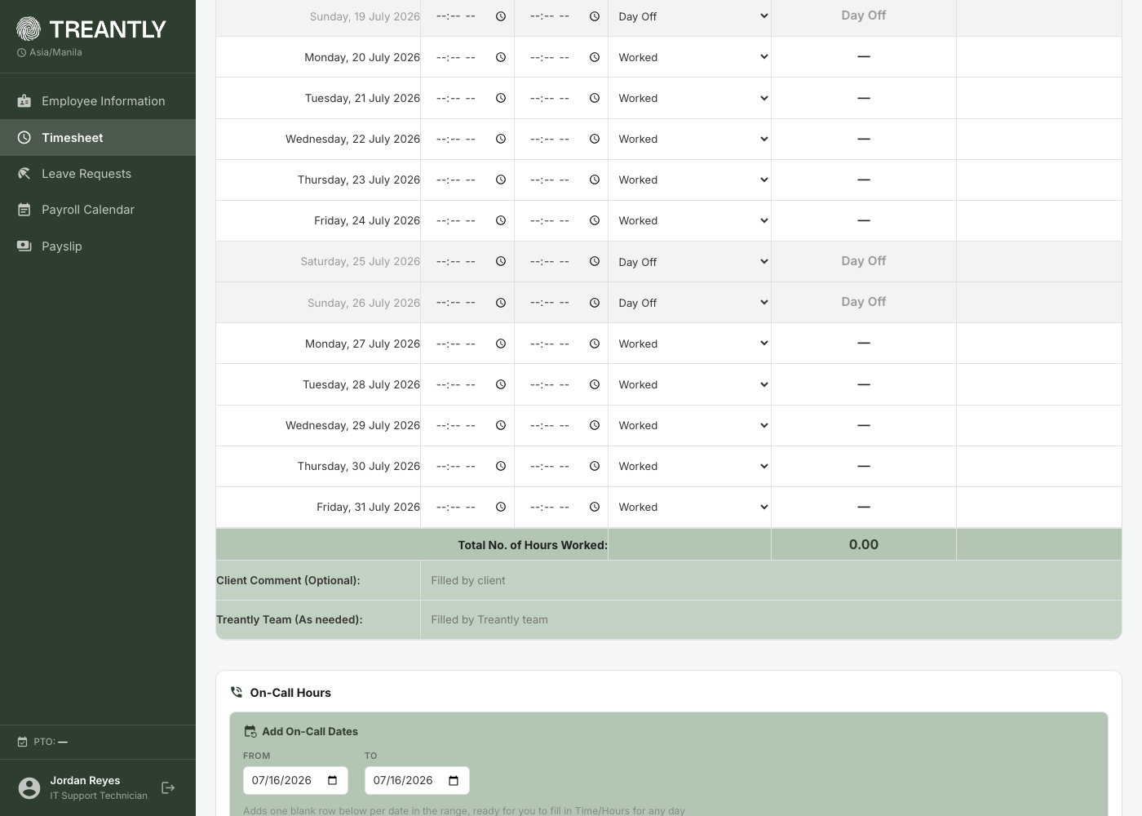
Add On-Call Dates — pick a date range and click Generate to add a row for each day.
Each generated row has Date From, Time In, Date To, Time Out, Hours, and Remarks. Time In/Out and Hours are optional — logging just the date is enough to count as an on-call day; only fill in Time and Hours for days you actually worked. Remove any row you don't need with the ✕ button.
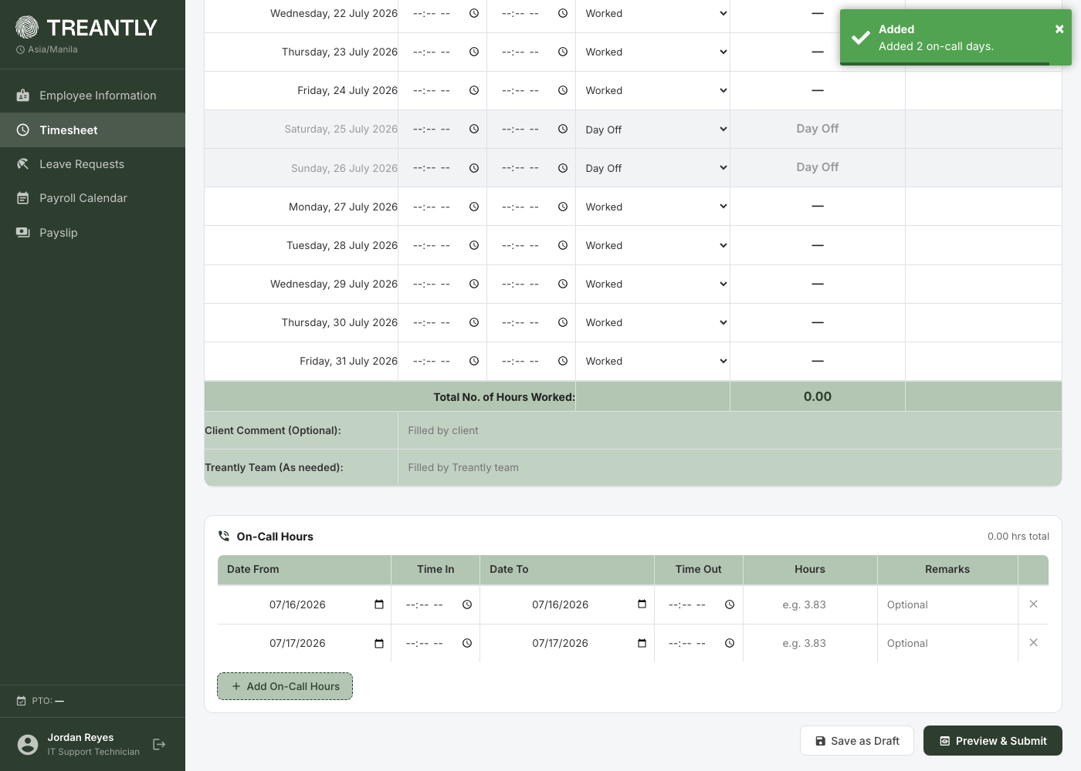
Generated on-call rows — fill in Time and Hours only for the days you actually worked.
💡
If your account earns an on-call stipend, a "Stipend applies" badge appears next to the On-Call Hours total once you've logged at least one entry — it also shows how many separate rotations count (each distinct start date is its own stipend). Before payroll runs for the period, this shows an estimate (your per-stint rate × rotations, in USD); once payroll is finalized, it changes to a See payslip link instead, since that's where the real converted amount lives.
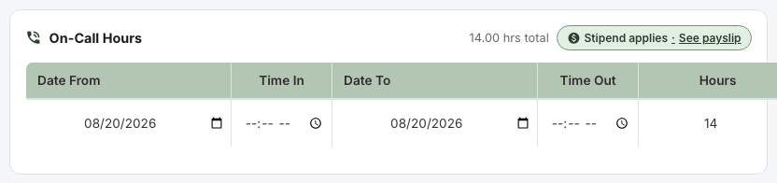
The On-Call Hours card with a stipend applying — payroll for this period is already finalized, so it links straight to the payslip instead of showing an estimate.

Saving and submitting
Button | What it does
Save as Draft | Saves your progress without submitting. You can keep editing later — nothing is sent for approval yet.
Preview & Submit | Opens a full read-only preview of the timesheet before it's finalized.
In the preview, you'll be asked to confirm an accuracy checkbox ("all information provided is true, accurate, and complete"). If the period includes overtime, a second checkbox acknowledging the specific OT hours is also required before Confirm & Submit becomes clickable.
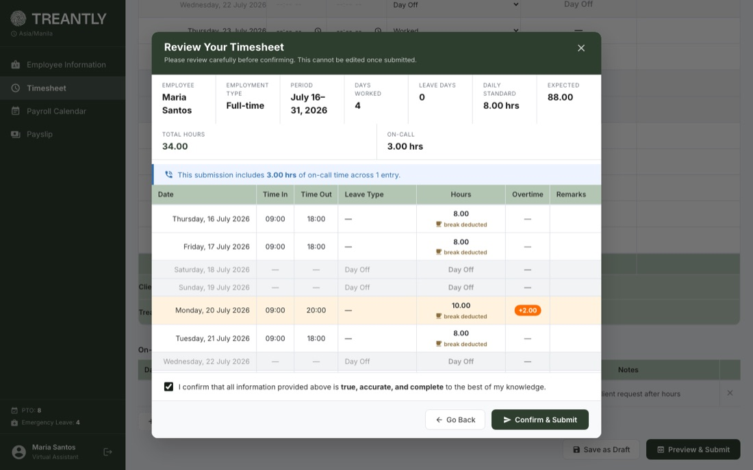
The submission preview — full daily breakdown, an on-call notice, and the accuracy confirmation checkbox.
🔒
Submitting locks the timesheet. Once submitted, the period becomes read-only — you can't go back and edit it yourself. If something needs correcting, contact your Treantly team to have it unlocked.

My Timesheets (history)
Every timesheet you've submitted, filterable by period, with its current status:
Draft Submitted Approved Client Rejected Revision Requested
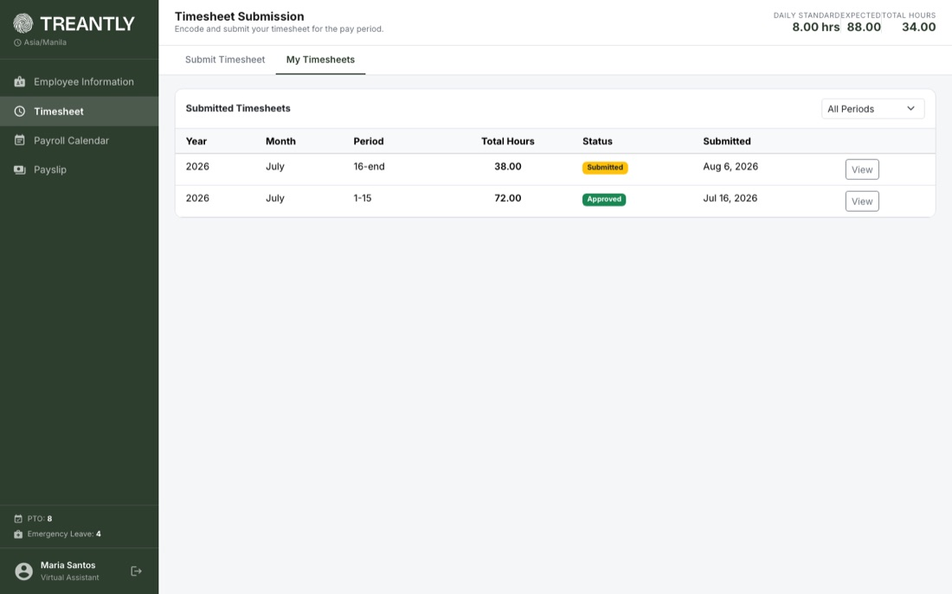
My Timesheets — every period you've submitted, with its status and a filter by period.
💡
A "Submitted" timesheet doesn't have to wait for a human. If no one reviews it within a set number of days, it moves to Approved on its own — you'll see the approver listed as the system rather than a person's name if you check its history. This is normal, not a sign something was missed; it just means no one had a correction to make.
⚠️
If a client rejects your timesheet ("Client Rejected"), you have 24 hours from the rejection to revise and resubmit it yourself — no need to wait for your Treantly team. You'll get an email with the reason and the exact deadline, and the form unlocks automatically while that window is open, even if the period's normal submission deadline already passed. If your 24-hour deadline would fall on a Saturday or Sunday, it's automatically pushed to Monday at the same time instead. After the deadline, it locks again and you'll need to contact your Treantly team to reopen it.
Click View on any row for a read-only breakdown: the full daily log, any approver comments/history, on-call entries, and payroll deductions or adjustments tied to that period.
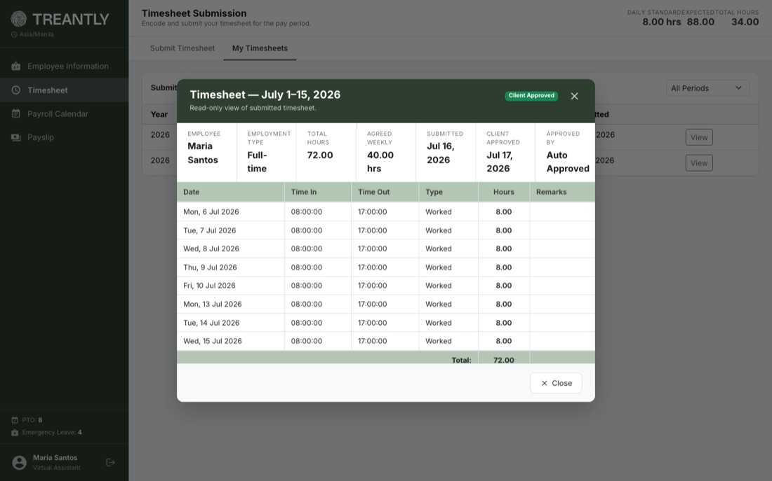
The read-only view of a past timesheet, including who approved it and when.
↑ Back to top

4Payroll Calendar

Schedule tab
A banner at the top tells you at a glance whether timesheet submission is currently open (with the due date and days remaining), not yet open for the next period, or whether no schedule has been published yet. Below it, every period for the year is grouped by month, with the period you're currently in marked current. Use the Card / List toggle to switch how the schedule is displayed — Card shows each period as its own block per month, while List shows the same fields as compact single-line rows for faster scanning. Either way, each period shows its work dates, working days, expected hours, submission open/due dates, and payroll date.
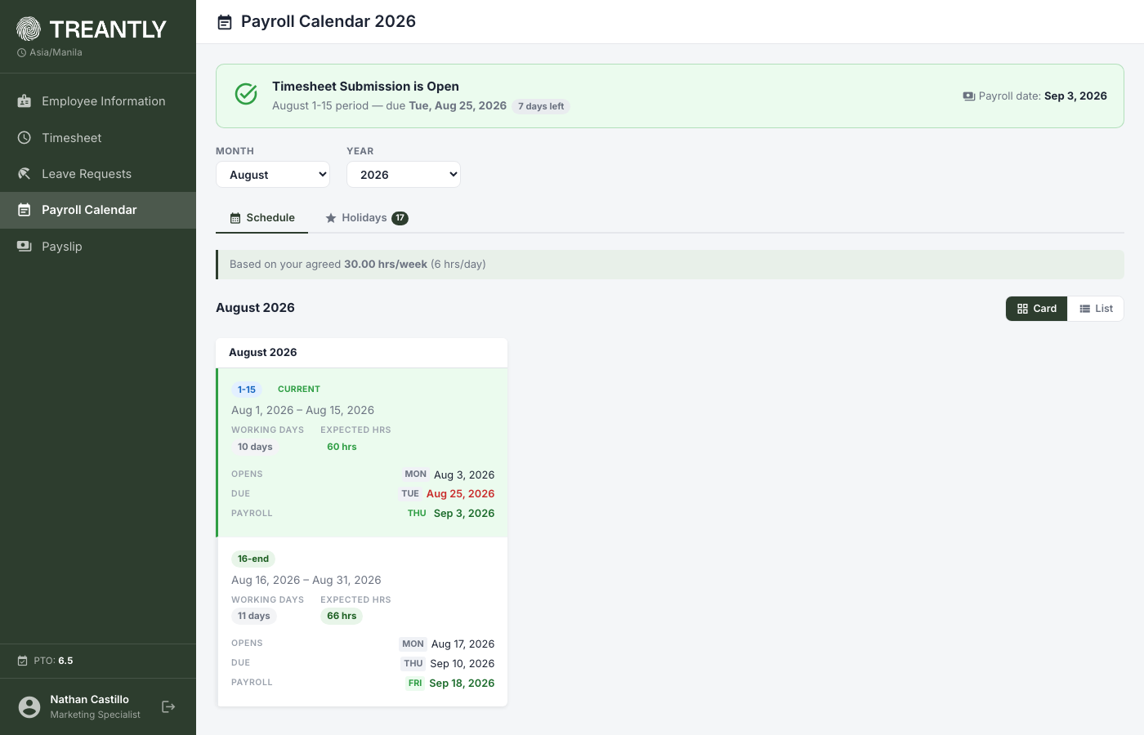
The schedule in Card view, with the current period's status banner up top.
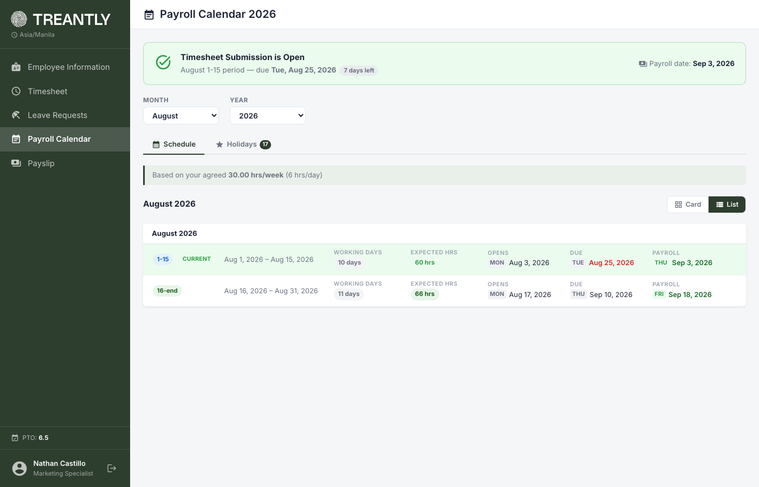
The same schedule in List view.

Holidays tab
Company holidays for the year, grouped by month, each tagged Federal or Company and marked observed where it's been shifted to a working day.
💡
This tab is informational — it doesn't change how you submit hours. If you're paid a fixed monthly rate, a holiday doesn't reduce your pay and you don't need to log anything for that date. If you're paid hourly, a holiday has no automatic effect either way — you're only paid for hours you actually log, same as any other day, with no extra holiday rate.
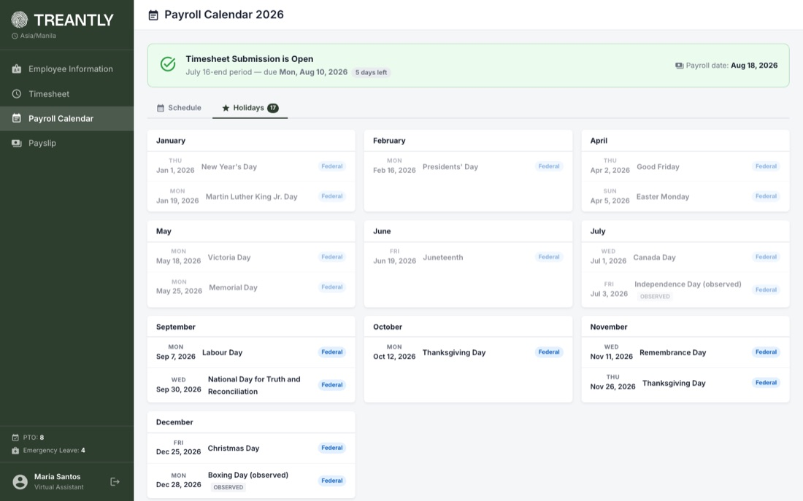
Company holidays, grouped by month.
↑ Back to top

5Payslip
Lists your finalized payslips — a period only shows up here once accounting has calculated and locked payroll for it. Filter by year and month, then click View on a period for the full salary slip: gross pay, itemized deductions, net pay, any incentives or adjustments, and the final amount.
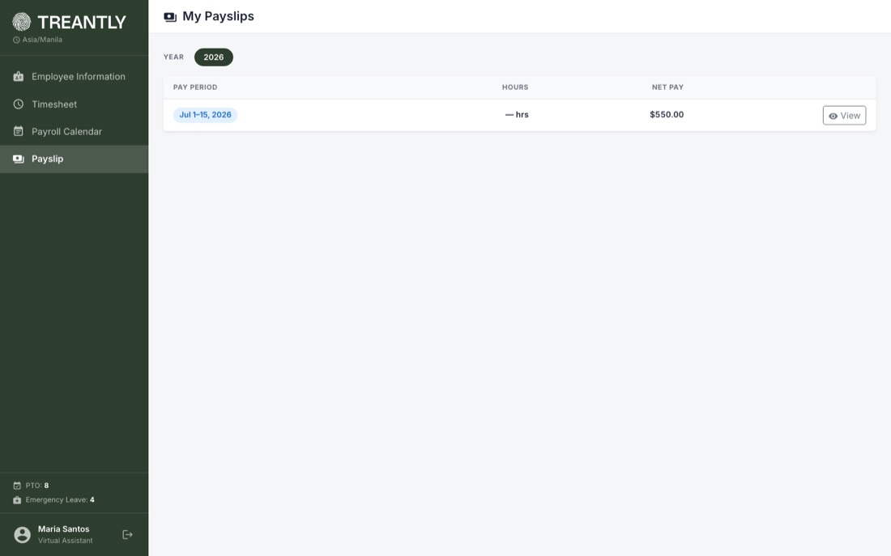
Payslips are grouped by year — only periods accounting has finalized appear here.
🖨️
Use Save as PDF in the preview to download a copy for your records. Note that the final amount is subject to standard transaction and foreign exchange fees.
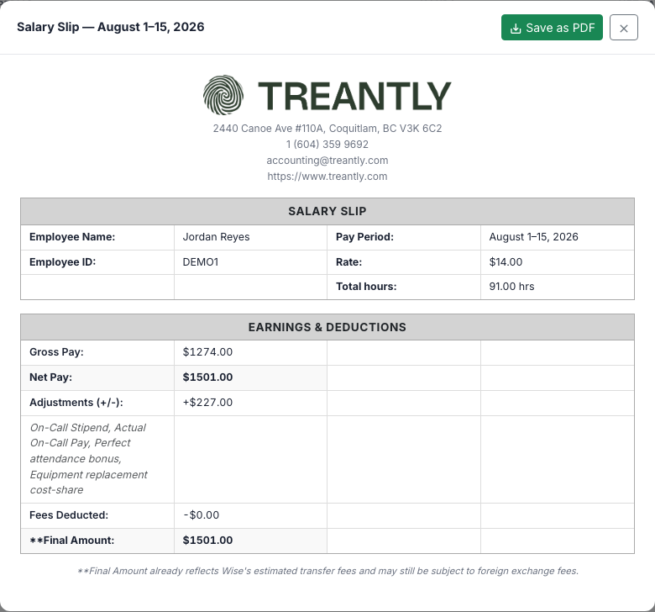
The full salary slip: gross pay, deductions, net pay, and the final amount.
💵
Adjustments (+/-) is a combined total: any named Payroll Adjustment (a bonus, a cost-share deduction, etc.) plus on-call stipend/pay, netted into one signed amount. When there's more than one item behind that total, a short note listing each one appears on its own line right below it.
💡
A loan repayment deduction shows on your payslip as Others, not "Loan" — that's deliberate accounting terminology, not a mistake. Every other deduction (HMO, etc.) shows under its own real description.
↑ Back to top

6Tips & Troubleshooting
Issue | What to check
Can't submit my timesheet | Make sure the submission window hasn't closed, you've entered at least one worked day, and any on-call row you started filling in has both Time In and Time Out set (or neither — a bare date on its own is fine).
Overtime flagged when I don't think it should be | Check your Work Schedule on the Employee Information page — overtime is measured against your scheduled hours (including breaks), not a flat 8 hours. If the schedule looks wrong, contact your Treantly team.
Confirm & Submit won't work, says hours are over expected | Overtime isn't enabled for your account, and this period's total is above what's expected for it. Either remove the extra hours or contact your Treantly team to confirm the overtime and enable it for you.
My timesheet is locked and says HR already recorded my hours | HR brought your hours in directly for this period (through their own Import Hours tool) — often because a period was being backfilled while you still had a draft open. Your hours for this period were already recorded, so there's nothing left to submit here. Contact your Treantly team if the recorded hours look wrong.
No On-Call Hours section on my timesheet | On-call logging only appears if it's been enabled for your role. Contact your Treantly team if you believe it should be.
Need to fix an already-submitted timesheet | Submitted timesheets are locked. Contact your Treantly team to have the period unlocked for revision.
Locked out after failed logins | Wait and try again, and double-check your Assistant ID and Client Code with your Treantly team.
Can't log in anymore after my last day | If your employment has ended, portal access stays open for 3 days past your End of Contract date so you can still submit a final timesheet, then it's disabled. If you still need access past that window, contact your Treantly team.
A payslip I expect isn't showing up | Payslips only appear once payroll for that period is finalized by accounting — it isn't available the moment a timesheet is approved.
Treantly Assistant Portal — for questions not covered here, reach out to your Treantly team or accounting@treantly.com.

