Timesheet Review Manual
Timesheet Review Manual

Treantly

Timesheet Review Manual
Reviewing, approving, and correcting submitted timesheets — for HR, HR-Admin, Accounting & Super Admin
Covers: Timesheets tab · Rejecting a Timesheet · Payroll Adjustments · Missing/Draft tab
In this manual
- Getting Started
- Reviewing the Timesheets Table
- Importing Historical Hours
- On-Call, Stipends & Overtime
- Approving a Timesheet
- Rejecting a Timesheet
- Payroll Adjustments
- The Missing/Draft Tab
- Tips & Troubleshooting

From Submission to Payroll-Ready
flowchart TD A["Employee submits timesheet (TA Portal)"] --> B["Shows as Submitted on the Timesheets tab"] B --> C{"Looks right?"} C -- Yes --> D["Approve"] C -- No --> E["Reject (reason required)"] E --> F["Employee corrects and re-submits"] F --> B B -- No action taken within the wait period --> D2["Auto-approved by the system"] D --> G{"Needs a bonus, deduction, or correction?"} D2 --> G G -- Yes --> H["Add a Payroll Adjustment"] H --> I["Ready for Payroll tab"] G -- No --> I
💡
The auto-approve wait period depends on the client's Email Delivery setting (see the Approver column table below): for Individual clients, the clock starts at submission; for Bulk clients, it starts when that batch's notification email actually goes out, not when the employee submitted. Currently 5 days either way. A timesheet auto-approved this way shows "System (auto-approved)" instead of a person's name — see Section 2.

1Getting Started
Timesheet review lives at Accounting → Payroll in the sidebar, which opens the Timesheet List page. It has six tabs — Timesheets, Missing/Draft, Margin Alerts, Payroll, Wise Exports, and Audit Report — sharing one filter bar (Year / Month / Period / Search) and 6 stat cards above them. This manual covers the first two tabs; the other four have their own manual.
💡
A Refresh button sits next to the page title. This page only reloads its data when it first opens or when you change the filter — it never notices something changed elsewhere, like a payroll approver approving from a link in their own email. Click Refresh to pick that up without losing your place (current page, open tab, etc.) or reloading the whole browser tab.
Stat card | Shows
Total Submitted | TA portal timesheets submitted for the period.
Pending Submissions | Employees who haven't submitted yet.
Billed Hours | Regular + Overtime + On-call hours actually worked this period — the hours there's something to bill for.
Unbilled Hours | Unpaid leave taken (unpaid full-day, unpaid half-day, unpaid holiday) — no work was done, so nothing to bill.
Overtime Hours | Total hours worked beyond 8/day, summed across the period.
Payroll Status | A live percentage, not a static label. Before the period is finalized it's submitted ÷ (submitted + pending) — i.e. how much of the period has been submitted. Once the period is finalized and its Wise export is approved, it switches to showing what percentage has actually been paid out via Wise (the same count the Wise Exports tab's own badge is built from, so the two numbers can't disagree). Color follows the percentage: red at 0%, orange while partial, green only at 100%.
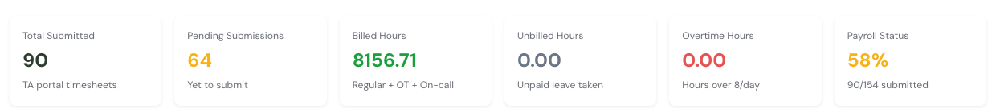
The 6 stat cards above the tabs — Total Submitted, Pending Submissions, Billed Hours, Unbilled Hours, Overtime Hours, and Payroll Status.
⚠️
Not everyone sees the same buttons. Approve and Reject are only available to Super Admin, HR-Admin, and Accounting — plain HR can view everything but can't act on it. Export Missing is narrower still: Super Admin and Accounting only. Payroll Adjustments have no role restriction — anyone who can open this page can add, edit, or delete one.

2Reviewing the Timesheets Table
Each row is one employee's timesheet for the selected period. Columns, left to right:
Column | Shows
Employee | Name, Employee ID, submission date, and any OT/On-Call badges (see below).
Client | Client code — hover it to see the full client name.
Approver | The client-side approver(s) on file for that employee. Shows "No approver set" if none exists yet.
Email Delivery | How that client receives timesheet emails — Individual (per submission) or Bulk (one digest email). Set on the client record, not here.
Period / Hours / Rate | Standard identifiers.
Gross Pay / Deductions (-) / Net Pay | Filled in once payroll has been calculated for this period on the Payroll tab — blank until then.
Incentives / Adjustments (+/-) | Manual overrides entered on the Payroll tab, not here.
Final Amount / Currency | The calculated payout, once available.
Status | See the table below. A timesheet brought in through Import Hours (see next section) carries an extra Imported badge next to its status, so you can tell it apart from a normal TA Portal submission at a glance.
The search box above the table matches on employee name, Employee ID, client code, or client name — so you can pull up every timesheet for one client just as easily as one employee. It no longer searches as you type — that used to fire a request on every keystroke, which was tripping a rate limit on these endpoints. Press Enter or click the Search button next to the field to run it. This is a separate action from the Refresh button described above: Refresh just reloads whatever period/filters are already selected without re-running the search, while Search applies the current search text against the current period.
Status badge, exact label shown:
Draft Submitted Client Approved Client Rejected Approved Revision Requested Expired
Client Approved / Client Rejected come from the client's own Partner Portal — see the Partner Portal Manual for what that side looks like. Approved is Treantly's own final sign-off, separate from and after any client decision.
💡
When a client rejects a timesheet, the employee now gets a 24-hour self-service window to revise and resubmit it themselves — no need for HR to unlock it, and this applies even if the normal 3-day submission deadline already passed. If that 24-hour deadline would land on a Saturday or Sunday, it's pushed to Monday at the same time instead, so the employee isn't expected to catch it over a weekend. They also get an automatic email with the rejection reason and the deadline. You only need to step in with the manual Unlock action (see below) for one still stuck as Client Rejected after that window has closed.
💡
Under the status badge, a small line of text shows who actually approved it — either a real name, or "System (auto-approved)" if no one acted before the auto-approve window ran out (see the callout below). This is the fastest way to tell a genuine client sign-off apart from one that just timed out.
Click the + button on a row to expand it. The expanded view shows, top to bottom: any client comment, a history of approver actions (who approved/rejected and when), the daily log (Date / Time In / Time Out / Type / Hours / Remarks), an On-Call Hours table if applicable, Payroll Adjustments if any, and a Payroll Summary strip once calculated.
☕
A row with Break in the Type column is an employee-reported unpaid break, not a leave type -- it shows the exact time the break started and ended, contributes nothing to Hours, and simply documents why the surrounding worked time doesn't add up to the full shift span.
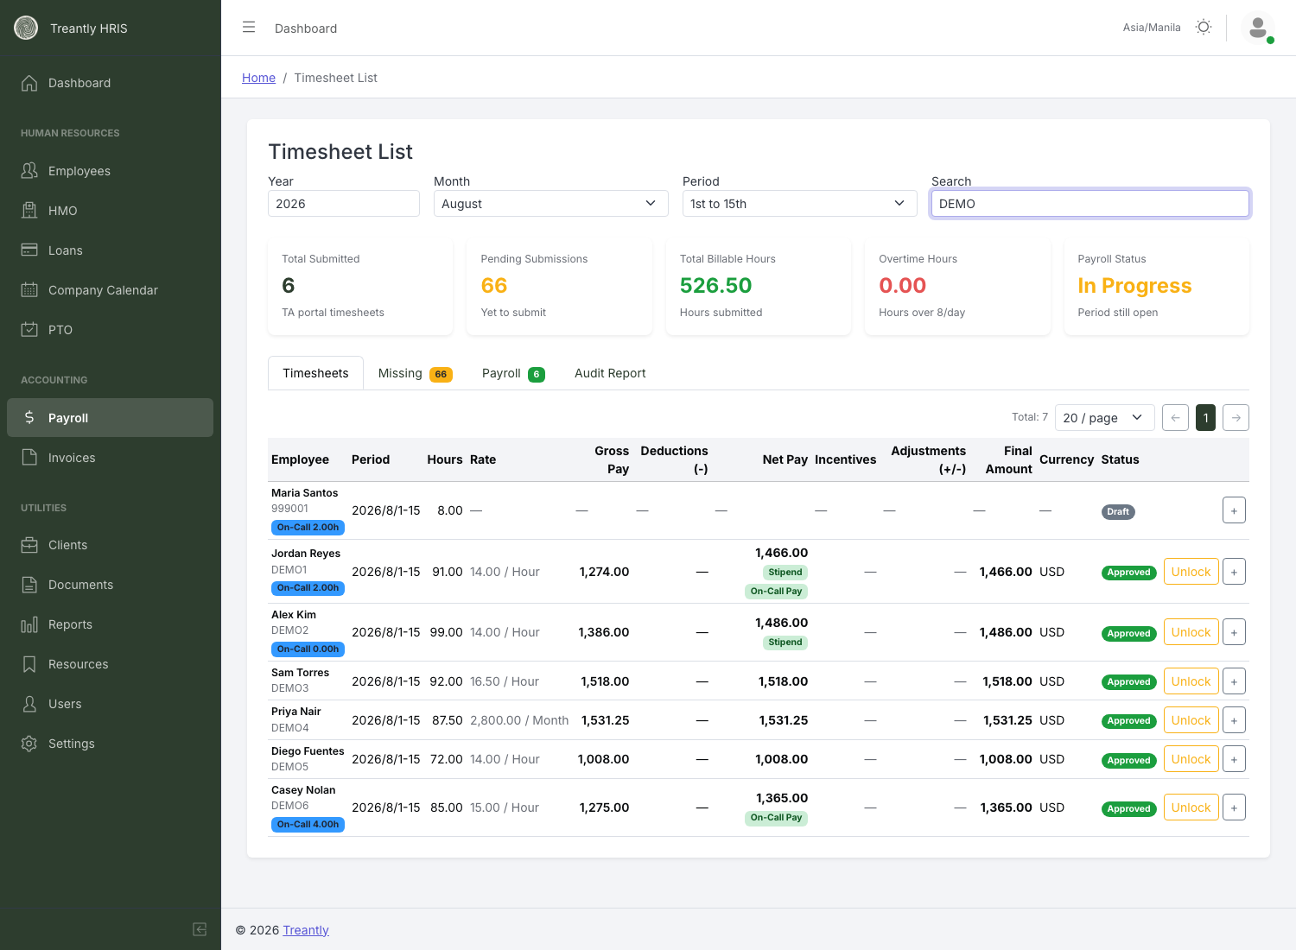
The Timesheets tab: status badges, On-Call badges, and (once calculated) payroll figures side by side.

3Importing Historical Hours
For periods that were tracked in a spreadsheet before the employee was on the TA Portal, use Import Hours instead of re-typing every row by hand. It's on the Timesheets tab, in the same line as the pagination controls.
- 1Set the Year, Month, and Period in the filter bar at the top of the page — every imported row is filed under whatever's selected there. Then click Import Hours.
- 2The dialog shows that same Year / Month / Period, greyed out — it can't be changed from inside the dialog. To import for a different period, close it and switch periods in the filter bar first.
- 3First time doing this? Click Download template in the dialog for a blank Employee ID / Email / Hours file with one example row already filled in.
- 4Choose the file — .xlsx, .xls, or .csv.
- 5Click Upload.
Each row is matched to an employee by Employee ID first, falling back to email address if there's no ID match. A timesheet is created already Approved, so it's payroll-ready immediately — there's nothing left to click through. It carries the Imported badge next to its status so it's clearly distinguishable from a normal TA Portal submission.
💡
Got a corrected version of a file you already imported? Check Overwrite rows already imported for this period before uploading — it replaces any row this period already has, as long as that row also came from an import. It has no effect on a real employee submission; those are never touched by an import, checked or not. Leave it unchecked for a normal first-time upload.
💡
A Draft row (employee started it in the TA Portal but never hit Submit) is always overwritten by an import, regardless of the checkbox above — a draft isn't a real submission (see the Missing/Draft tab), so there's nothing to protect. If that employee still has the page open when this happens, their next Save or Submit is blocked with a message explaining HR already recorded their hours for this period.
Situation | What happens
Employee already has a timesheet for that period. | If that row is a Draft, it's always overwritten. Otherwise the row is skipped and listed as a duplicate — it never silently overwrites an existing timesheet, unless you've checked Overwrite rows already imported for this period in the upload dialog (see below). Without that box checked, correct a bad import the older way instead: Reject (unlock) that specific row from the Timesheets table first, then re-upload — the re-upload replaces it. Either way, the checkbox path only ever applies to a row that was itself brought in through Import Hours; a real TA Portal submission is never overwritten by an import, checkbox or not.
A row can't be matched to an employee, or its hours value isn't valid. | That row is skipped and listed as an error with the reason — every other row in the file still imports normally.
The employee is separated (Terminated, Resigned, Endo, Client/VA Withdrawn, AWOL) and past their portal access grace window. | Skipped and listed as an error — same grace window (end of contract + 3 days) that gates their TA Portal login. Prevents backfilling hours for someone who left long ago; a separated employee still within their grace window can still be imported.
The file's own Year/Month/Period columns don't match what you selected above. | The row still imports — this is just a heads-up, listed as a period mismatch so you can double-check it wasn't the wrong sheet.
💡
If anything was skipped or flagged, a Download Report button appears after the upload. It's an Excel file with three tabs — Errors, Duplicates, and Period Mismatches — so you can fix the source file and re-upload instead of scrolling through the on-screen list.
⚠️
This is for backfilling history, not for the current period. An employee who has TA Portal access should still submit through the portal directly — that keeps the daily log, client comments, and approval trail intact. Import Hours only records a lump total, not a day-by-day breakdown.

4On-Call, Stipends & Overtime
If an employee logged any on-call time, their row carries a badge like On-Call 2.00h — the total on-call hours for the period. Expanding the row shows the full breakdown:
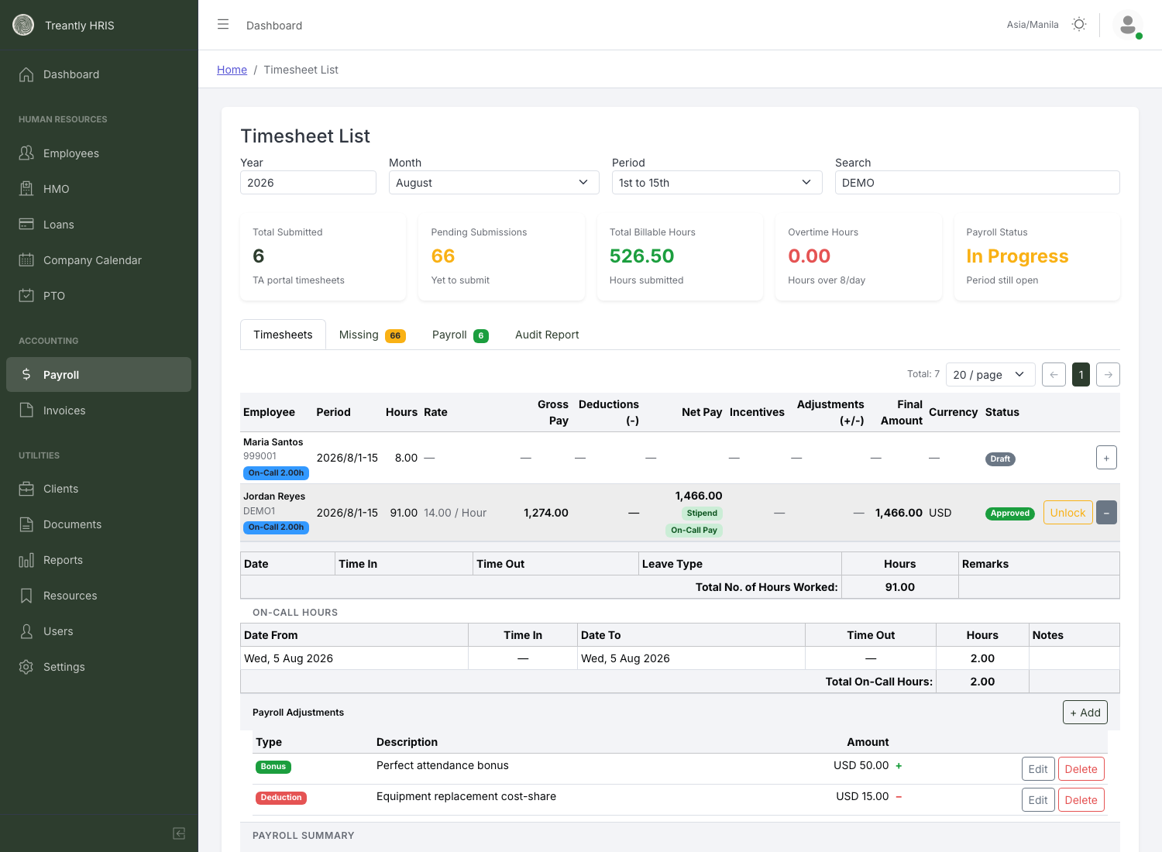
On-Call Hours table: Date From/To span the shift (often overnight), Time In/Out are optional reference fields — Hours is what's actually paid.
Date From and Date To can differ, since real on-call shifts often cross midnight. Time In/Time Out are optional — the employee types Hours directly rather than having it calculated from the times, so don't expect the hours figure to always match a time-in/time-out subtraction.

Stipend and On-Call Pay badges
Once payroll is calculated, an employee eligible for an on-call stipend shows a green Stipend badge next to Net Pay — hover it for the exact math. A separate green On-Call Pay badge covers actual on-call hours paid at the employee's rate. These are independent: an employee can have neither, either, or both in the same period.
💡
The stipend is a flat amount, capped at one per calendar month — logging on-call across several separate days in a period doesn't multiply it, and having on-call activity in both the 1-15 and 16-end periods of the same month still only pays it once (whichever period gets calculated first claims it). The badge's tooltip shows how many separate on-call days were logged that period, for context, but that count no longer changes the amount.

The OT badge vs. the Overtime Hours stat card
⚠️
These are two different things that happen to look related. The orange OT badge on a row means the employee tagged at least one logged day with an overtime type (regular, rest-day, or holiday OT) — it's a flag, not a measurement. The Overtime Hours stat card at the top of the page is a separate calculation: total hours worked beyond 8/day, summed across everyone, regardless of whether those hours were tagged as OT. A timesheet can show the OT badge with a low stat-card contribution, or vice versa — don't assume one implies the other.

5Approving a Timesheet
Click Approve on a row with status Submitted or Client Approved. A confirmation dialog shows exactly what you're approving before it takes effect:
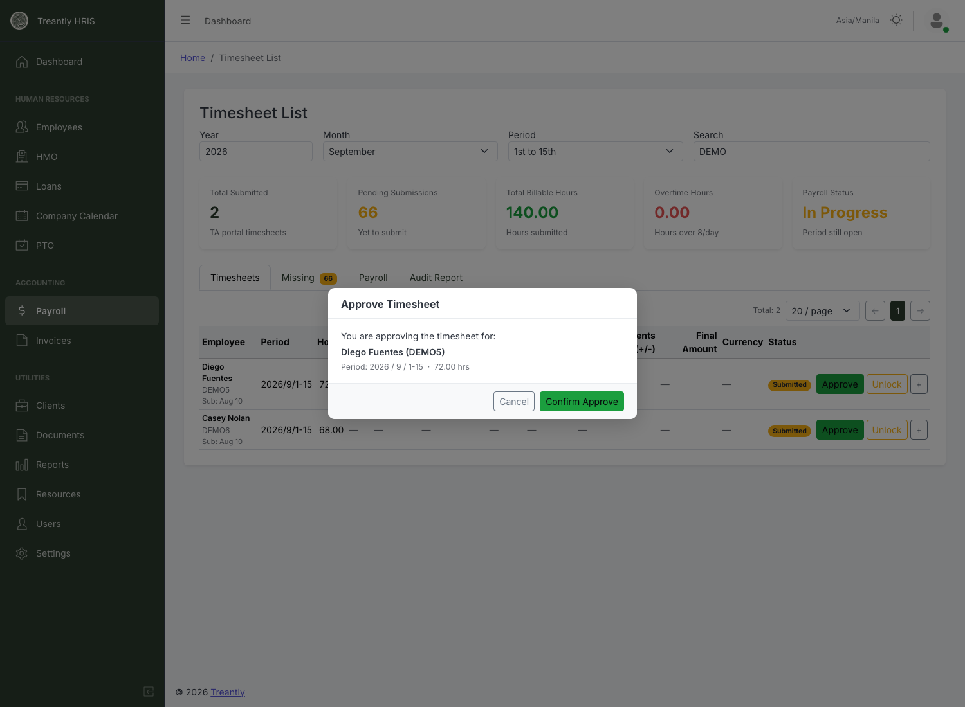
Approve Timesheet — confirms employee, period, and hours before finalizing.
This is Treantly's own sign-off, independent of whatever the client already decided in their Partner Portal.

6Rejecting a Timesheet
If a timesheet needs a correction — wrong hours, a missing day, anything the employee needs to fix themselves — click Reject. It's available from Submitted, Approved, Client Approved, or Client Rejected — including a timesheet you haven't approved yet, so an obviously-wrong submission can be sent back immediately without approving it first.
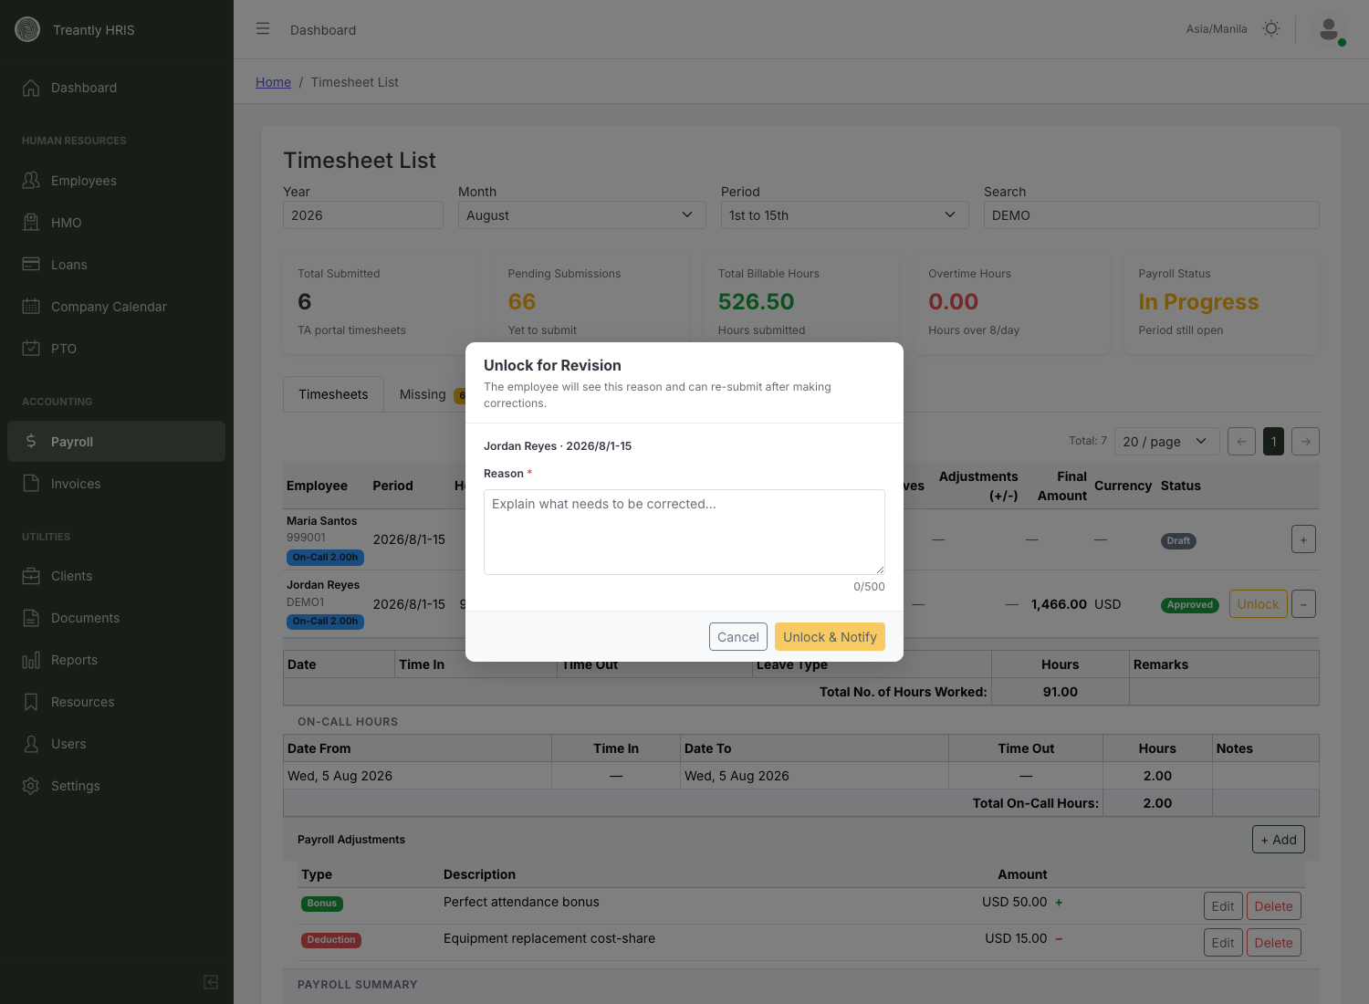
Rejecting requires a reason — it's shown to the employee and reopens the timesheet for editing.
A reason is required. Once submitted, the timesheet's status changes to Revision Requested and the employee can edit and re-submit it from their own portal.
⚠️
"Reject & Notify" doesn't send an email or push notification. Despite the button's wording, the employee only finds out by opening their TA Portal, where the timesheet shows a "Revision Requested" status and your reason. If it's urgent, message the employee directly — don't rely on this button alone to get their attention.

7Payroll Adjustments
Inside an expanded row, the Payroll Adjustments section lists itemized bonuses, deductions, and corrections tied to that employee's period — separate from loan/HMO deductions, which show here too but are read-only (sourced from the employee's actual loan/HMO records, not editable from this list).
Click + Add to create one:
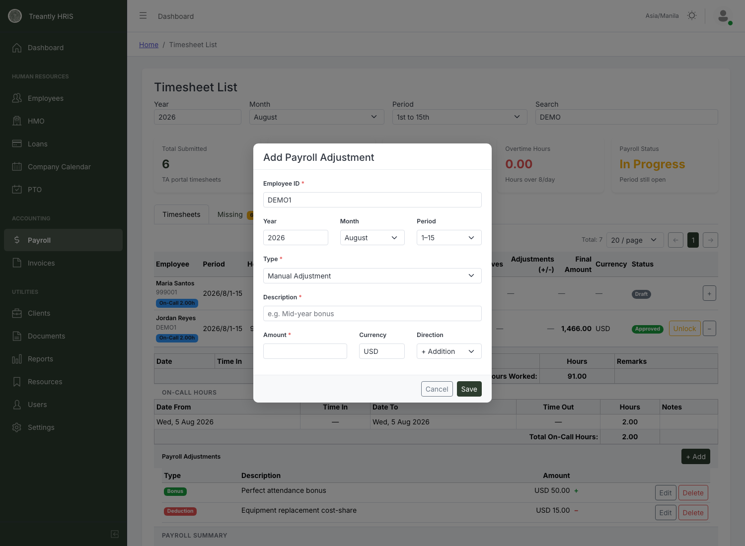
Add Payroll Adjustment — Employee ID/Year/Month/Period only appear when adding, not when editing an existing one.
Field | Notes
Type | Bonus, Deduction, Tax, Manual Adjustment, or Other.
Direction | + Addition or − Deduction — this, not the Type, controls whether it adds to or subtracts from pay.
Currency | Defaults to USD if left blank.
Editing an existing adjustment reuses the same modal without the Employee/Year/Month/Period fields. Deleting one asks for a plain yes/no confirmation naming the adjustment's description.
💡
These feed into that employee's Adjustments (+/-) total wherever payroll is calculated. If the period has already been finalized on the Payroll tab, recalculate afterward so the change is reflected in the final numbers.

8The Missing/Draft Tab
Two sub-tabs, both scoped to active employees who haven't submitted a timesheet for the selected period (newly hired employees who've already started, minus anyone already marked as processed for payroll or whose contract ended before the period began):
Sub-tab | Who's in it
Missing | Hasn't touched their timesheet for this period at all — no row exists yet.
Draft | Started filling it in (in the TA Portal) but hasn't hit Submit. A draft is still not a real submission — it still counts as missing, and the employee still gets the reminder email, exactly as if they hadn't started at all.
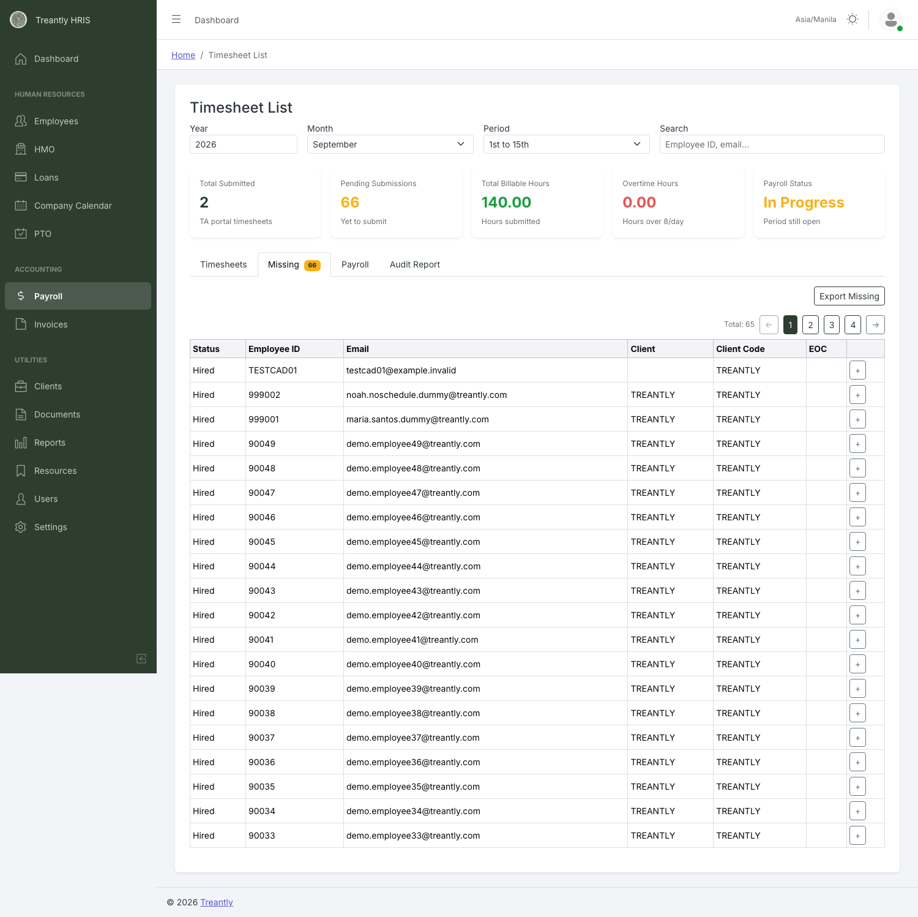
Missing: everyone expected to have submitted by now, but hasn't.
Columns: Status, Employee ID, Email, Client, Client Code, EOC (end of contract). Expand a row for a bit more detail (role, date hired).
Export Missing (only on the Missing sub-tab, not Draft) downloads a spreadsheet — note it has a narrower column set than the on-screen table (Employee ID, email, first/last name, client code, date hired, end of contract; no status, client name, or role).

9Tips & Troubleshooting
Situation | What's actually happening
Approve/Reject buttons aren't showing for me. | Those actions are limited to Super Admin, HR-Admin, and Accounting. Plain HR can view but not act.
I rejected a timesheet but the employee says they never heard about it. | Expected — "Reject & Notify" doesn't actually send anything. They'll only see it next time they open their TA Portal. Message them directly if it's time-sensitive.
A timesheet has a red "Late" badge. | It was submitted after that pay period's own end date (the 15th, or the last day of the month) — still accepted normally, just flagged. Not related to the separate 3-day window that force-expires a timesheet that was never submitted at all.
A timesheet has the OT badge but the Overtime Hours stat card barely moved. | They're unrelated metrics — the badge flags a tagged overtime type per day, the stat card sums actual hours over 8/day. Not a bug.
An on-call entry's Hours don't match Time In/Time Out. | Expected — Hours is typed directly by the employee, not calculated from the times. Time In/Out are reference only.
I added a Payroll Adjustment but it's not reflected in the Final Amount. | If that period was already calculated on the Payroll tab, recalculate it — adjustments don't retroactively update figures that were already computed.
An employee I know was hired isn't showing up on the Missing tab. | Check their hire date and end-of-contract date — the tab only includes employees whose hire date falls on or before the period and whose contract (if any) hasn't already ended before it.
I re-uploaded a corrected file but nothing new came in. | If those rows already imported successfully the first time, they're now duplicates and get skipped on purpose. Only rows that were previously errors, genuinely new, or belong to a row you specifically unlocked first will import.
An hourly employee's pay looks off for an imported period. | If their rate changed mid-period, Calculate can't split an imported row's hours by date (there's no daily log to split against) — it pays the full amount at the current rate instead, and flags this under the Calculate warnings on the Payroll tab. Check the warning list and adjust manually if the split actually matters for that employee.
A row imported fine but showed up as a "period mismatch" in the report. | Not an error — it just means the file's own Year/Month/Period columns didn't match what you selected in the Import Hours dialog. Worth a quick look to confirm you picked the right period, but it didn't block the import.
Treantly HRIS — Timesheet Review Manual · For questions, contact your system administrator.

